# **Chapter 1: Introduction**

## **1.1 Introduction to the project**

Ilam district, located on the eastern corner of the country is where most of the tea for Nepali Tea Traders is grown and harvested. The green tea along with churpi, lollipop etc. are those few products that people from all over the country as well as several foreign countries crave for but do not get to enjoy enough because of various factors.

My project Ilam Tea Garden will be a commercial website that can connect the tea market of Ilam all over Nepal. People from all places will be aware of the tea market that the place flourishes on. The projects will be focusing on commercializing those products that are uncommon to other places but easily manufactured in Ilam.

## **1.2 Background of the project**

As an underdeveloped place of a developing country, Ilam tea market until now does not have a proper information system to commercialize their products and are being marketed manually through communications only. Because the place is located at the eastern border of the country, most of the market has been taken by India rather than our own.

Mediators who are involved in the projects are highly benefitted while trading these products and those mediators does not include people who trades through online information system. Not all of those mediators are from the place of product manufacture which in turn does not support the economic status of the place. People from around the country have only heard of Ilam as a place where Tea grows but they have not actually used the product. Even in the capital city, most people are unaware of the products. Farmers too are unaware of the massive market that their products can create in the national as well as international level. Several companies are focused on increasing the tea market, but are limited by the lack of a proper information system to properly market the products.

## **1.3 Overview of the project**

1. **Features**

* Features to signup, login as well as apply for memberships to all users.
* Sellers will be able to market their products along with their qualities, quantities, locations of manufacture, seller details etc.
* Buyers will be able to view, order, make, get manufacture details.
* Features of online booking.
* Buyers and sellers can directly communicate to make the marketing trustworthy.

1. **Overview**

The project will be directly involved in marketing products manufactured in Ilam which will help in increasing the economic standard of the people along with the GDP of the place. People from all over Nepal will get to enjoy the local products of Ilam easily. The project will be highly focused on giving a household name to those products

## **1.4 Aims and Objectives of the project**

1. **Aims**

The main aims of the projects are as follows:

* To create an e-commerce market for the unique products of the place which will help increase the low economic standard of the people of the place.
* To make the products accessible to people in every places of the country.

1. **Objectives**

* Throughout the project I will be using as well as learning more of programming languages like Php, JavaScript, Bootstrap.
* A functional signup and login system for users will be track their progress.
* Additional membership features to allow users to be a part of the community and benefit from it.
* To make users feel easy while operating with our projects I will be focusing more on eye-catching icons rather than pictures and texts.
* An online booking system will be created to make sure people get the value of the project whenever they want.
* A community forum will be created to allow users to make a discussion.

# **Chapter 2: Analysis of the project**

## **2.1. Introduction to analysis**

In simple terms, analysis is the process determining any given situation. In software development, it is the process of determining the requirements, user expectations, predicting risks and collecting data of all possible factors related to a new or an already launched product. It helps in breaking down the project in manageable chunks or parts which helps to understand the problem aspects. It helps in the estimation of time and budget needed for the project which is an essential part of a project success.

The importance of performing analysis on my project are:

* It helps in gathering information about the different aspects of tea farmers and manufacturers business. I.e. their way of business operation, rules and regulations.
* It helps to gather information to check the feasibility of the project.
* It helps to understand the problem being faced by the local people easily.
* It enables to understand the requirement of the local people of the area and develop a project that suits both their requirement and knowledge.
* It also facilitates in clarifying the local people on what they think they want from what they actually need.
* This process will also help my project to understand the market areas that are currently involved in the products related to my project.

## **2.2. Analysis Methodology**

The type of analysis technique undertaken for project development is known as analysis methodology. There are several approaches to software development namely soft system approach, hard system approach, combined approach etc. Among these methodologies, I am going to undertake soft system methodologies.

### **Soft System Approach**

This methodology is an approach to system modelling for solving general project problems and developing feasible as well as desirable changes based on a differentiated group of people and other factors of social, cultural, ethical kinds etc. It shows that user interaction in any project is of the same importance as the technical considerations. Unlike other methodologies that analyses “how a system should operate”, this methodology provides a soft analysis on ‘what the system should do ‘and ‘how the system should do it.

The process of soft system approach is carried out in several steps.

**Stage 1: Finding out problem**

This step includes activities like interviews and observations to try to understand the problem that the project will be solving as deep and as wide as possible.

As a residence of Ilam myself, I have observed the scenario myself and through them the major problems related to the local products of the place were found to be:

* The local products of the place not getting a proper national market.
* Mediators benefitting from the hard work of the local farmers and manufacturers.

**Stage2: Expressing the problem situation**

This step of SSM includes tasks of communication of the problem statement and to validate the analyst’s understanding of the situation and representing them using tools like Rich Pictures.

Rich pictures are used for giving an idea of the different factors that the problem influences and relate those factors. The rich picture of the situation is given in the picture below.

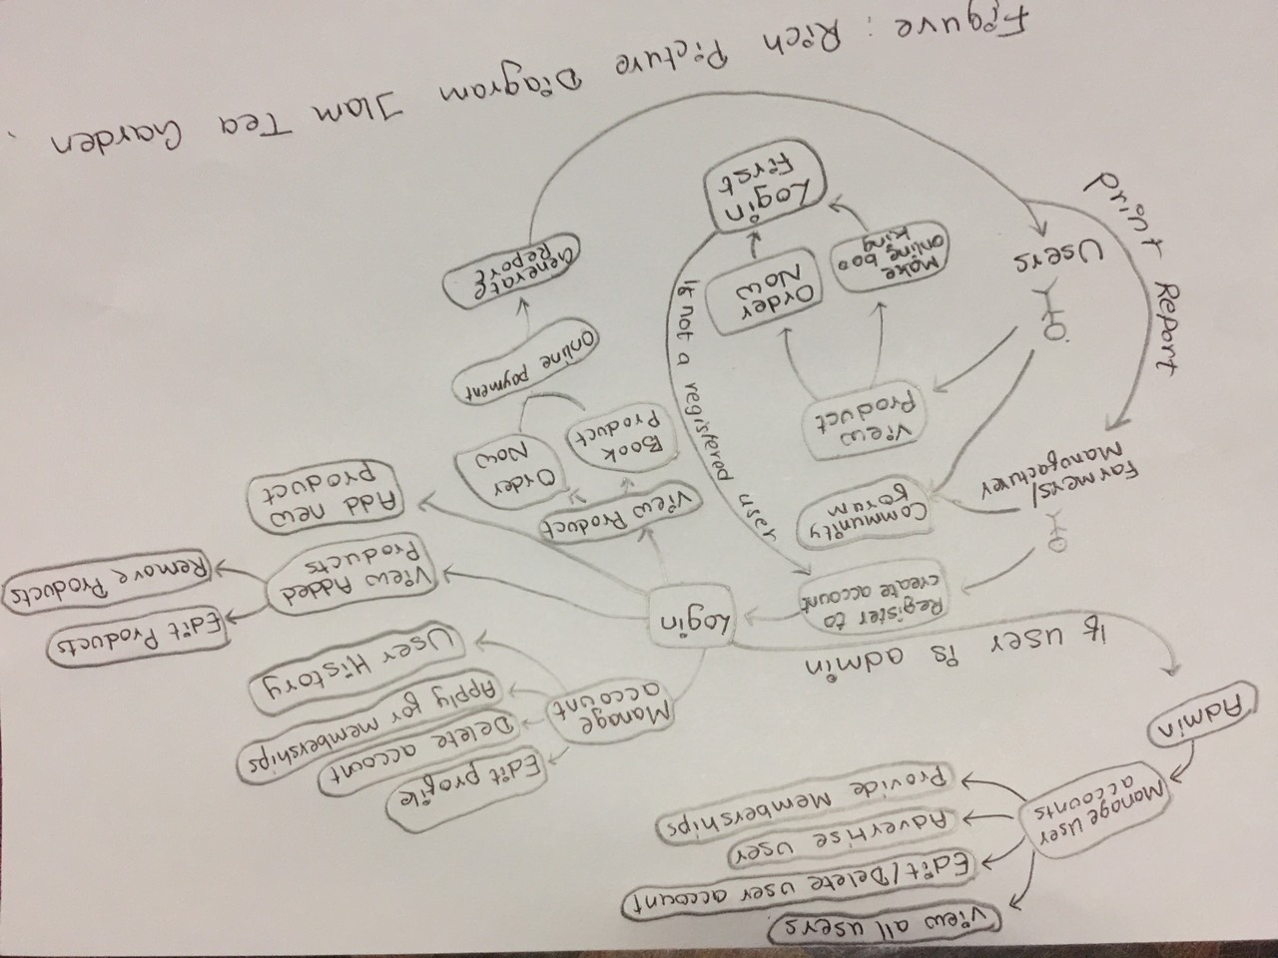

Figure 1 Rich Picture for IlamTeaGarden

**Stage 3: Deriving Root Definitions**

Root definition is the process of naming a system, which are short statements that describe the aims and functions of the system to be developed. They are of two types namely

* Primary Task Root Definitions focusing on the process
* Issue-based Root Definitions focusing on the problems.
* **Input-Output Diagrams**

This step of root definitions involves creating possible transformation processes using a single transformation process as much as possible.

Some of the input-output diagrams are shown below.

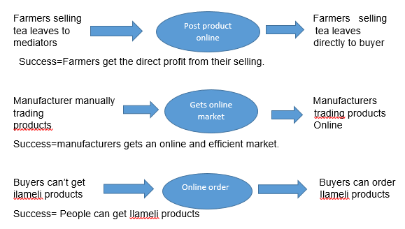

* **Root Definitions (Process based)**

A root definition has been derived from the list of input-out diagrams given above.

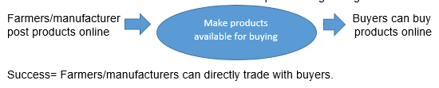

* **Performing the CATWOE Analysis:**

The type of analysis that focuses on the different elements of a project like **C**ustomer, **A**ctors, **T**ransformation, **W**orldview, **O**wner and **E**nvironment factors is known as **CATWOE.** The following elements were drawn out by undertaking this analysis on the project.

1. **C**ustomer = Product Buyers
2. **A**ctors = Farmers and Manufacturers
3. **T**ransformation= Allow direct trading between buyers and sellers.
4. **W**orldview=Farmers and manufacturers is benefitted and buyers get what they want.
5. **O**wners=Project Investors
6. **E**nvironmental constraints=Controlled Educational Environment

* **Root Definitions (Problem based)**

A root definition has been derived from the list of input-out diagrams given above.

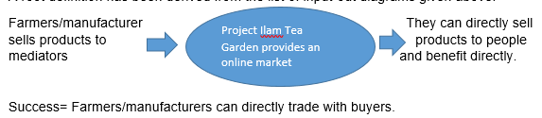

* **Performing the CATWOE Analysis:**

1. **C**ustomer = Product Buyers
2. **A**ctors = Farmers and Manufacturers
3. **T**ransformation= Mediators are eliminated between farmers/manufacturers and product buyers.
4. **W**orldview=Farmers and manufacturers are only benefitted and buyers get what they want.
5. **O**wners=Project Investors
6. **E**nvironmental constraints= Controlled Educational Environment

**Root Definition**

A system owned by project investors, where tea farmers/ local products manufacturer can directly sell their products to interested buyers without any mediators. With a feature of ordering and booking products between the two parties, the system will allow the sellers to get high benefit and buyers get to enjoy the local products of Ilam.

**Stage 4: Deriving Conceptual Models**

A conceptual model can be defined as a set of concepts combined to represent a system so as to make the viewer easily understand the different models of the system. It represents the different activities that the actors need to perform for achieving the designated transformations. By listing different activities and graphically relating them using monitor and feedback activities, a conceptual model is designed. The conceptual model for project is given below.

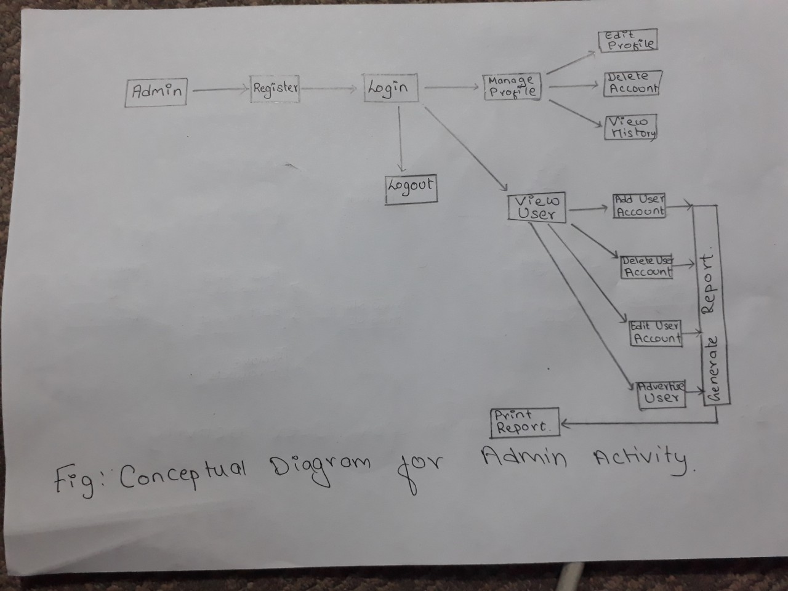

Figure 2 Admin activity conceptual model

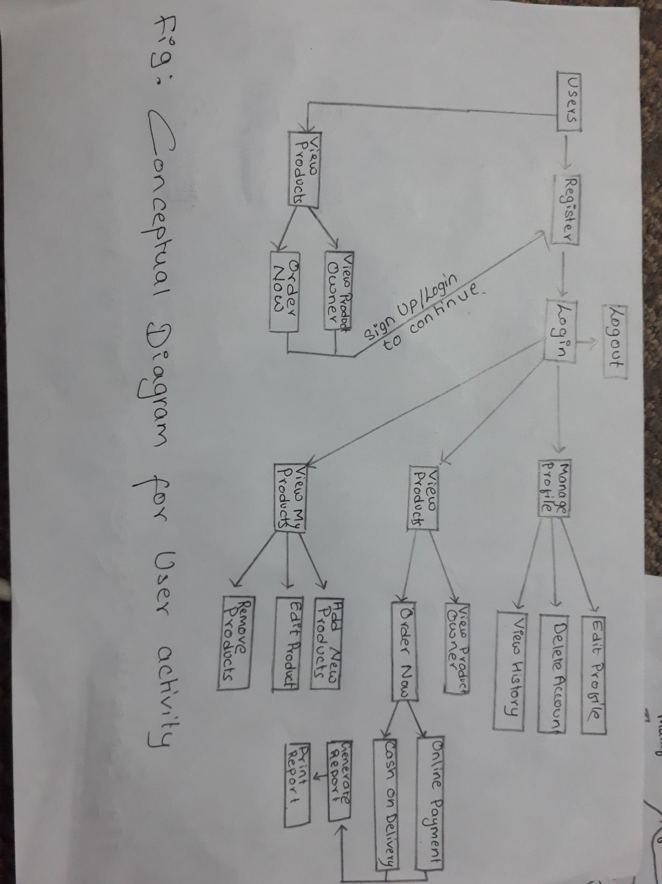

Figure 3 User Activity Conceptual Diagram

**Stage 5: Comparing the concept of the system with the actual system**

This step compares different aspects of a conceptual model with the real project developed since not everything will be pitch perfect and in conjunction to the conceptual model.

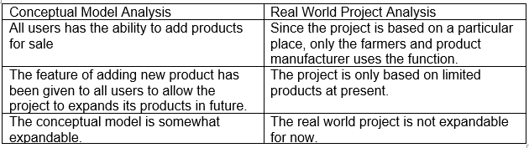

Figure 4 Table Comparing conceptual model and real world

**Stage 6: Analyzing Feasible and Desirable Changes**

This step of SSM follows activities to show the rich picture and conceptual diagram to people who are the major stakeholders of the project and other users who can help analyze the system model with the above diagrams. Some of the changes that have been analyzed are as follows

* The rich picture shows that all users can add products but since the project is based only on Ilam, it was taken into consideration that not all users can add products for sale for now.
* Community forum should link all users and admins to make a trustworthy project.

### **Feasibility Study**

The study undertaken to find out whether or not a project is practically possible in the real world scenario, its probability to success and its ability to do what a project aims for is known as feasibility study. These factors can be determined by understanding the cost, times and benefits related to the project. For a project to be successful, the project should have the ability to achieve its purpose with the benefit always greater than the cost required for the project.

The different feasibility study that I performed in my project are given in the table below.

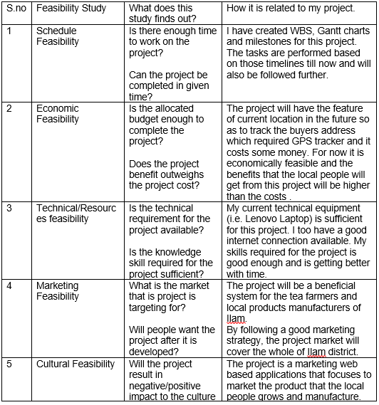

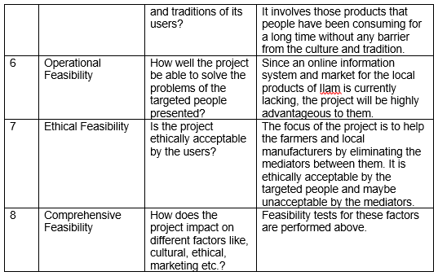

Figure 5 Feasibility Study table

## **2.3 Requirement Analysis**

### **Functional Requirement**

Functional requirement in project development are those features which are planned to be incorporated in a system being made. These requirements include technical features, hardware-software and their functionality to operate as per the needs of the system user.

The functional requirements of my project is introduced below along with its rationale and dependencies.

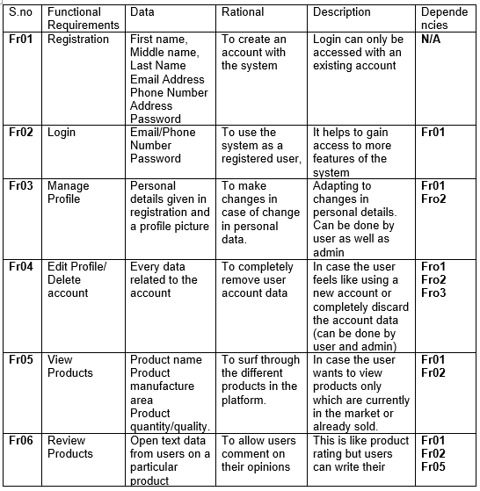

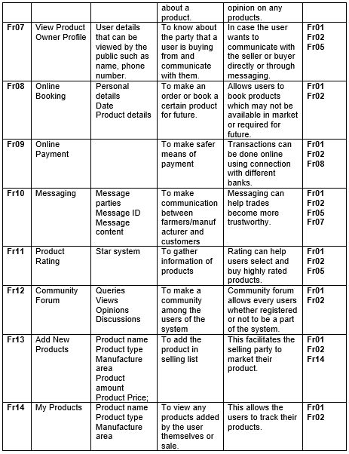

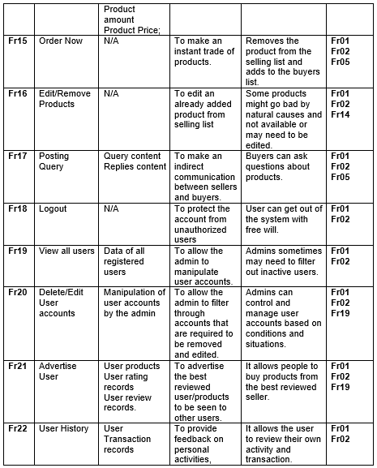

Figure 6 Functional Requirement Table

### **Non-Functional Requirement**

Those requirements that sets up specific criteria for judging the operation of a developed system is known as non-functional requirements. These non-functional requirements usually determine the quality attributes of the system rather than some specific behavior or functions. The non-functional requirement of my project is shown in the table below.

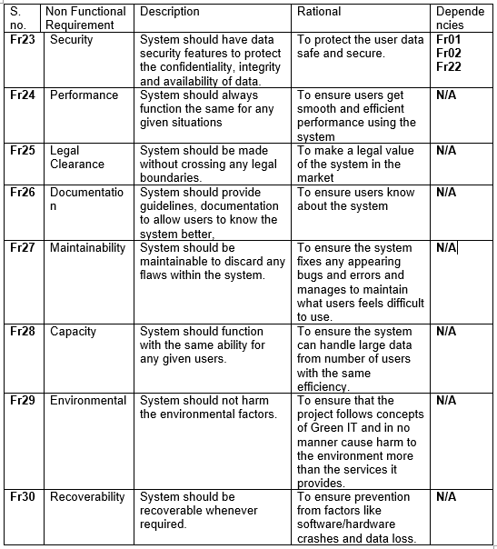

Figure 7 Non Functional Requirement Table

### **MoSCoW Prioritization**

Commonly referred as MoSCoW method, it is the technique for prioritizing requirements of a system. The level of priority for a system are Must Have, Should Have, Could Have and Won’t Have. This method determines what requirements are compulsory, optional and what a system will not have. This method is also applicable in our life represented by the figure below.

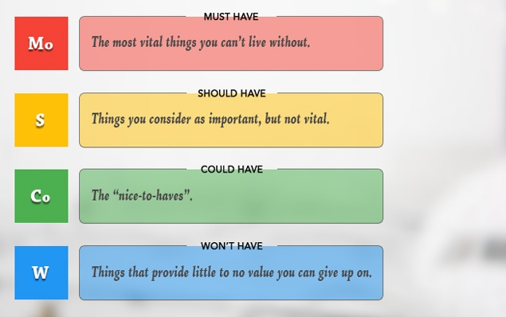

Figure 8 MoSCoW

The table below shows the prioritization of different functional requirements of my project.

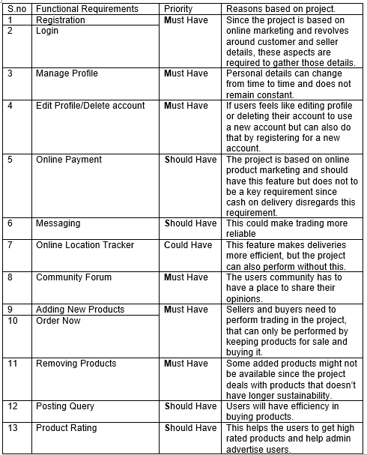

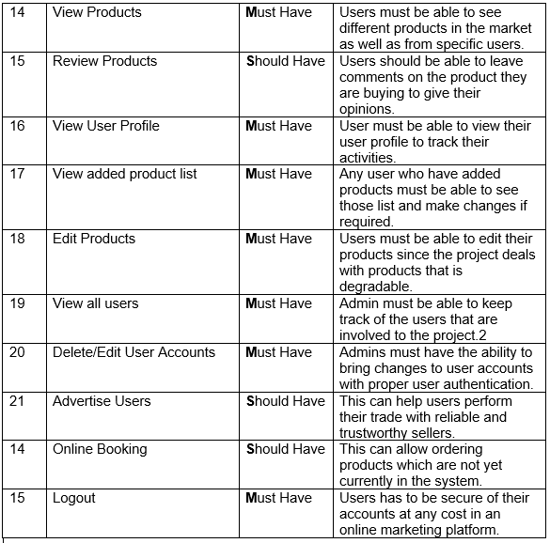

Figure 9 MoSCoW Functional Requirement

The table below shows the prioritization of different non-functional requirements of my project.

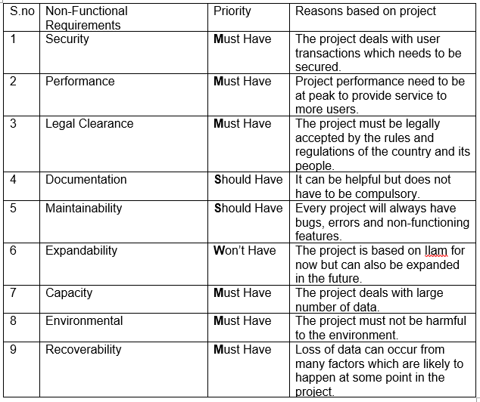

Figure 10 MoSCoW Non-Functional Requirement

This analysis conducted in my project gave the following information.

* It identified key requirements of my project.
* It identified any aspects that my project doesn’t require right now.
* It helped to identify future aspects of my project.

### **System Requirement Specification**

A system Requirement Specification is a set of documents details the features and functionality of a system to be developed. It also provides details on different hardware and software required while developing the project as well as what users will require to use the project.

The hardware/software requirements for my project is given below.

* Pre-project requirements

The hardware/software required for developing the project from initiation to deployment is known as Pre-project requirements.

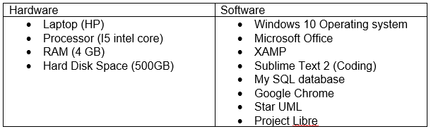

Figure 11 Pre Project system requirement

* Post project requirements

The hardware/software that is required at minimum to use the project by the user is known as post project requirement.

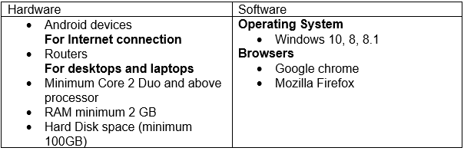

Figure 12 Post Project System Requirement

## **2.4 Use Case Diagram**

A use case diagram is a diagrammatic representation of the different entities of a system. It clarifies the role of different external parties on the functionality of the system commonly called actors. It is made to show the relationship of the external entities with the different aspects of the system shown in different use cases.

The advantage of creating this diagram on my project are as follows.

* It is an easy and understandable method of representing a system to the local people since it doesn’t have any technicality.
* Use cases evolve with each iteration and change in requirements can be traced easily.
* It helps to identify the role of different entities like farmers and manufacturers, customers and admin in a clear way.
* It shows the relationship of these entities with different functionalities

The use case diagram of my project is given below.

1. User Login System Use Case

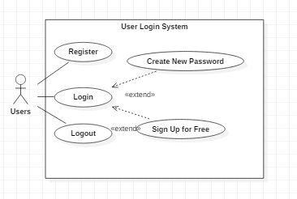

Figure 13 User Login System Use Case

Unregistered users will have to register their account first to create and account. After they are registered, they can login to the system. If in any case, the user forgets their password or need to sign up with another account, they can create a new password or sign up for free respectively as shown by the extend relation.

1. 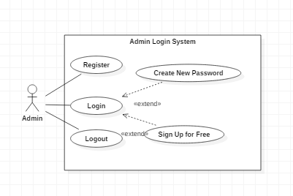Admin Login System Use Case.

Figure 14 Admin Login System Use Case Diagram

Users at first need to be registered as admin. After they are registered, they can login to the system. If in any case, the admin forgets their password or need to sign up with another account, they can create a new password or sign in respectively as shown by the extend relation.

1. Admin/Users Profile Use Case Diagram

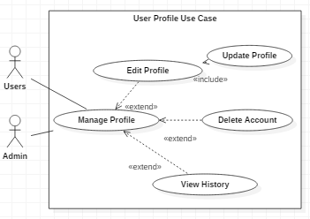

Figure 15 Admin/User Use Case Diagram

Both admin and users can manage their profiles in the system. They can edit their profile details, delete their account as well as view their activity history as shown by the extended relation. To update their profile though, both admin and users compulsorily need to make changes to profile as shown by the include relation.

1. Admin Functionality Use Case Diagram

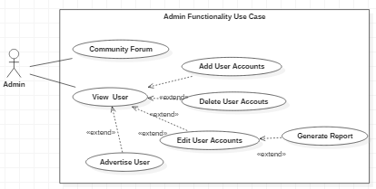

Figure 16 Admin Functionality Use Case Diagram

Admin can participate in the community and view all users. Admin can manipulate users by adding new users, delete user accounts, edit user accounts as well as advertise deserving users as shown by the extended relation below. It is compulsory to edit user accounts in order to generate report which is shown by the include relation.

1. Products Handling Use Case Diagram

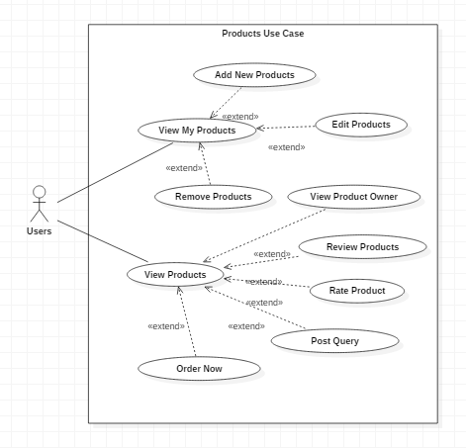

Figure 17 Products Handling Use Case Diagram

Users can either view products that are on sale or view their own products that are for sale. They can add new products, edit their products details as well as remove products based on circumstances as shown by the extended relation. After viewing products that are at sale users can view the product owner profile, review the products, rate the product, post any query and order the product as shown by the extended relation.

1. Product Order Use Case Diagram

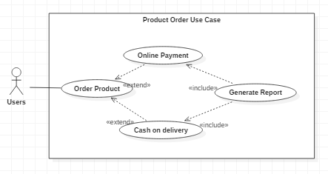

Figure 18 Products Order Use Case Diagram

After users order a certain product, they can either make an online payment or choose to pay can on delivery as per their needs. To generate payment reports it is necessary to perform these as shown by the include relation.

## **2.5 Natural Language Analysis (NLA)**

The process of identifying the different aspects of a system by using an unstructured text that are completely understandable to non-technical people is known Natural Language Analysis. It revolves around an unstructured text where nouns are selected as potential object candidates, verbs are selected as potential candidate methods and adjectives are selected as potential attributes. These three factors later help in the creation of different diagrammatic figures like class diagram, activity diagram, system architecture etc. These diagrams in turn play key roles for development of a system.

To perform Natural Language Analysis, an unstructured text related to the project is required. The scenario for my project is presented in the unstructured text below

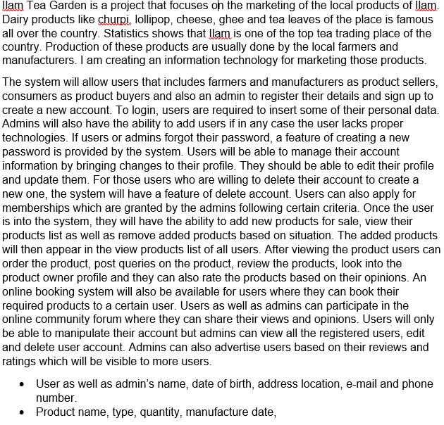

From the unstructured text given above **NLA** will be carried out in the following steps.

* Selection of nouns as potential candidate classes
* Selection of adjectives as potential candidate attributes
* Selection of verbs as potential candidate methods

The candidate classes, attributes and methods have been shown in the table below.

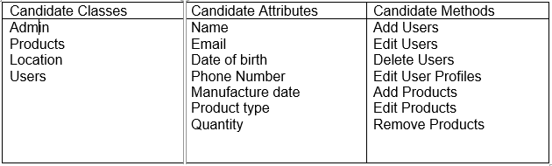

Figure 19 NLA Candidate Lists

### **Initial Class Diagram**

A class Diagram is a graphical representation of the blueprint of the system that shows the relationship between different classes, attributes and methods. A 3 section rectangular box is used for class diagram in which classes are kept at the top section, attributes in the middle section and methods or functions in the bottom section. These unique classes are then connected via different relationship types and thus this diagram is used in the implementation of the whole system.

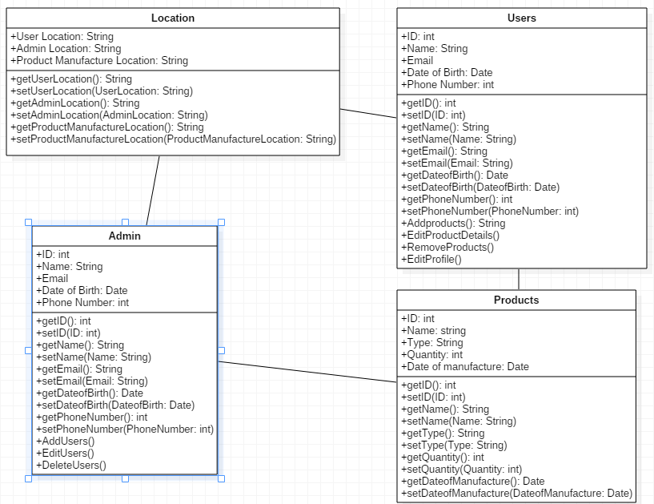

# **Chapter 3: Design of Ilam Tea Garden**

## **3.1 Introduction to design**

The third stage of software development that can be considered as a bridge between the analysis of a software requirement and implementation is known as design. This stage helps transform the gathered system requirement into suitable logical form with an intent to help the programmers in coding and implementation. This is one of the crucial step of software development that usually answers the **“How?”** aspects of software development. (i.e. how the system should look like, how it should perform etc.) Various diagrammatic models are created using different tools so as to answer the above questions.

The importance of this step on my project can be highlighted from the following points.

* It clarifies the ways and paths to be taken during the coding and implementation of project Ilam Tea Garden.
* Prototyping used in this process will allow the local people of my place to visualize what the system is going to look and function like.
* It makes uses of the different classes and objects generated during analysis and helps to create different diagrams which eventually helps to ease the programmers task.

For project Ilam Tea Garden, I will be designing 4 different models which are listed below.

* Structural model
* Behavior Model
* Database Modelling
* Architectural Model
* Prototyping

## **Structural Model**

Models that shows how different components, (usually objects and classes) and their relationships are organized in a system is known as structural modelling. Structural model diagrams reflect the static relationship of the different components in a system. Below are different structural model diagrams.

### **Class Diagram (Final)**

This class diagram makes use of relationships of objects at a greater depth and is more informative than an initial class diagram shown in the analysis stage. It is also called the blueprint of the system since the whole system is based on this diagram.

The justification for creating an in-depth class diagram for my project is given below.

* It makes my system more robust since the classes, objects and their interactions are pre-analyzed and determined without having to actually write programming codes.
* It acts as a structural foundation for writing the programming codes.
* Maintaining the system will be easy by referring to class diagrams instead of going through each lines of codes which will save a lot of time.

|  |  |  |  |
| --- | --- | --- | --- |
| S.no | Notations Used | Notation Name | Description |
| 1 |  | Association | To show links between two classes. |
| 2 |  | Composition | To show that a certain class has exclusive ownership over other class. |
| 3 |  | Classes | It shows the class name and its representing attributes |

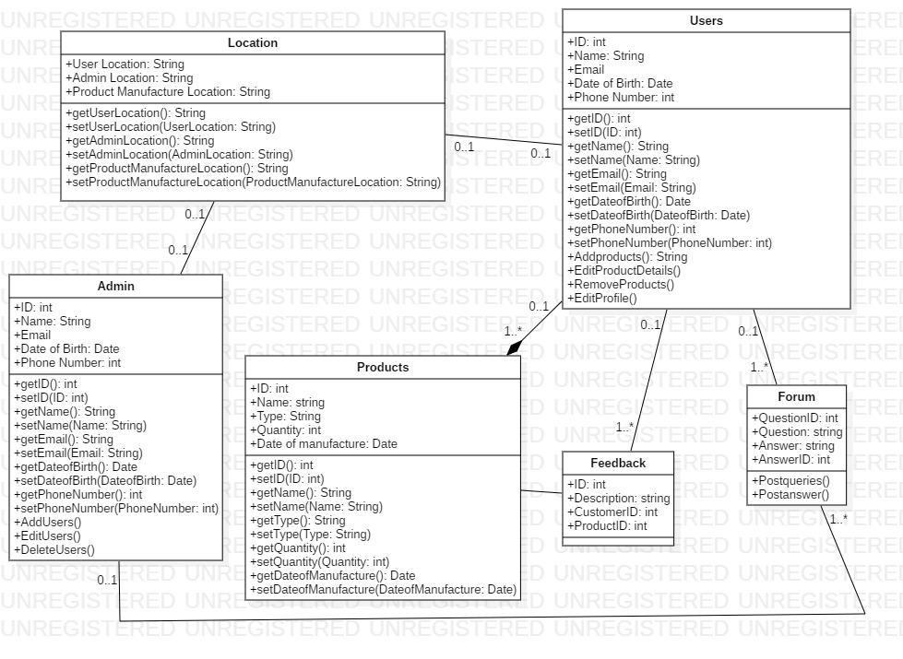

In the class diagram shown above, classes are associated with each other with different types of relationships like one to one and one to many. Since products are only dealt by users and admin does not have any relation to it, composition is used to relate those classes.

### **Data Flow Diagram**

The diagram that represents the flow of data within a system in an informative manner is known as Data Flow Diagram (**DFD).** It is a traditional approach to structural modelling which can be manual, automated as well as both at a time.

The justification for creating a Data Flow Diagram for my project is given below.

* The local people will clearly understand what the system represents because of the efficient communication that DFD provides.
* Data Flow diagrams are clearly understood by technical as well as non-technical audiences.
* It helps to describe the boundaries and scope of the system in a neat and clear way.

**Notations**

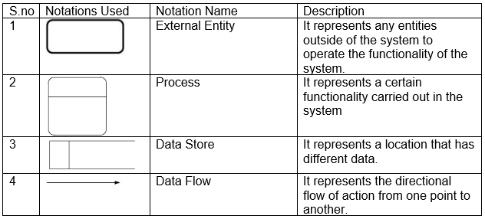

The data flow diagram for my project is given below.

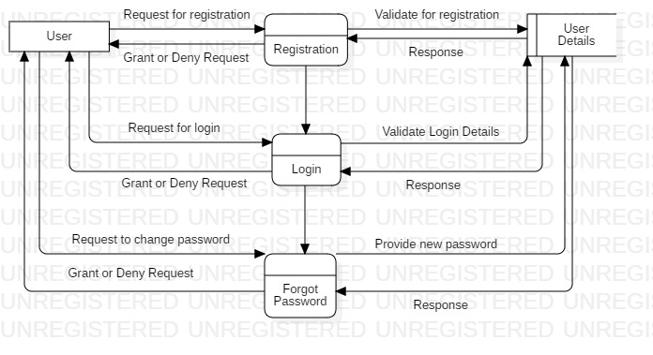

Figure 1 Registration and Login DFD

In the **DFD** above users need to register at first to create an account associated to the system by providing user details. Then they can gain access to the system by providing required and registered details. If in any case the user forgets their login password, the system will guide them to create a new password after validating your ownership of account.

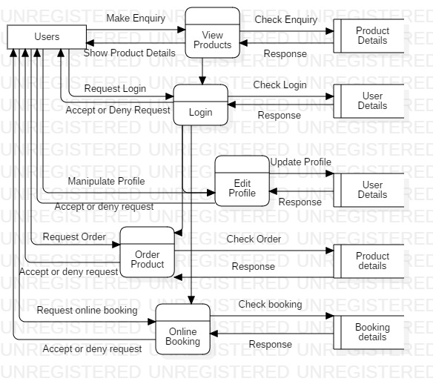

Figure 2 User Functionality DFD

In the **DFD** above, all users will have the ability to view products as well as the registered details associated with it. To use any other functionality though, they need to login to the system providing their login details. They will be able to manipulate their personal details by using the edit profile process, order products after viewing their details as well as make online booking of products by providing booking details. Each process has to accept the request of the user to successfully carry out the function.

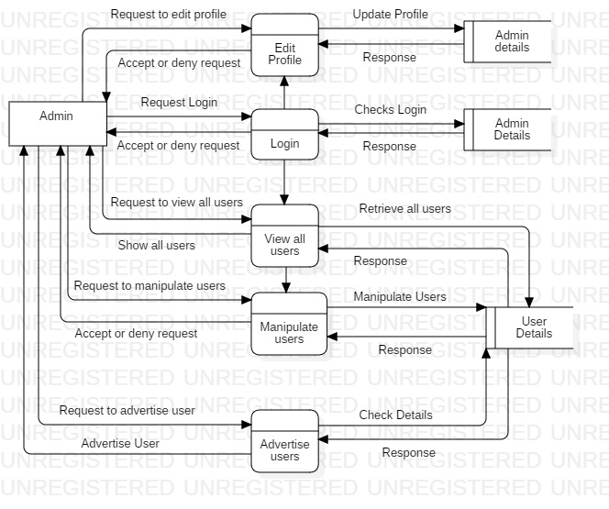

Figure 3 Admin Functionality DFD

In the **DFD** above, admins will be able to login and make changes to their profile just like users. In addition to this, admins will be able to view all registered users of the system including their details and can manipulate the user details. One more functionality of the admin is that they can request the system to advertise certain users and take some part of their details to be shown to every other user.

## **Behavior Modelling**

The type of modelling that shows how objects interact with each other to produce a particular behavior often specified by a use case is known as behavior model. They represent the overall dynamic system behavior during the execution of different functions. When a certain interaction is made, they show what happens or what should happen.

### **Activity Diagram**

A type of flowchart that is used to represent the flow of activity from one operation to the other in a dynamic manner is known as an activity diagram. It is crated to show the flow of message from one activity to other rather than one object to other, which other diagrams usually do.

The justification for creating an activity diagram from my project are.

* It will be easier to make the local people as well as every end user understand the work flow concept of the system.
* They can depict multiple conditional scenarios and actors by showing the workflow on every possible scenario.

**Notations**

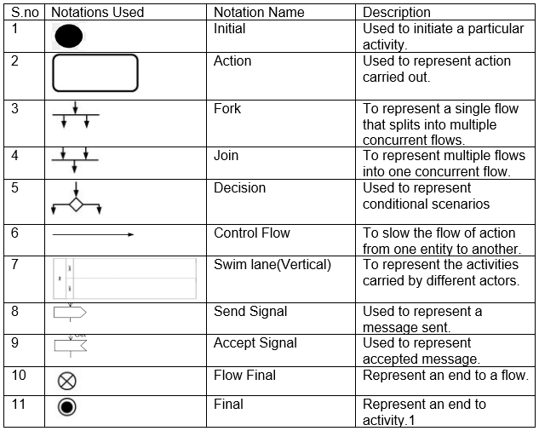

The activity diagrams of my project are given below.

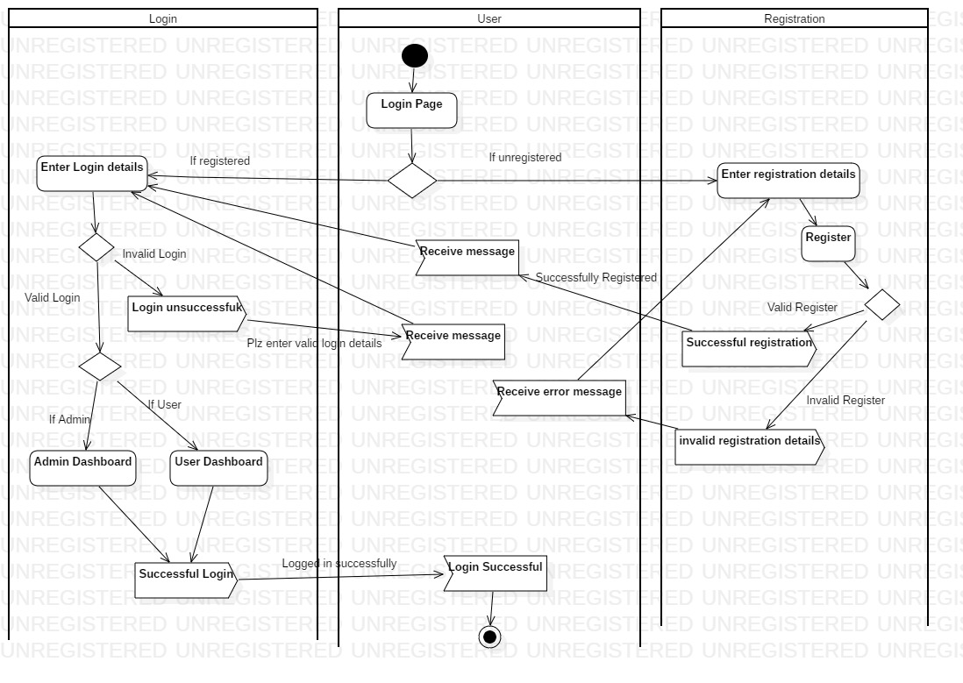

Figure 4 Login Activity Diagram

In the activity diagram shown above, the user starts the activity by opening the login page. A decision notation separates two conditions for registered and unregistered users. If the users are registered, they are asked to enter their login details. If the login is successful, the user will be either taken to user or admin dashboard depending on the role they have in database and the user will get the message of successful login. If the login details are invalid, the user will get the error message and will again be taken to the login page. On the other hand, if the user is unregistered, they are asked to enter their registration details which if successful sends a message to the user that registration is successful. If registration details are invalid, the user will get the message and will be taken back to the page.

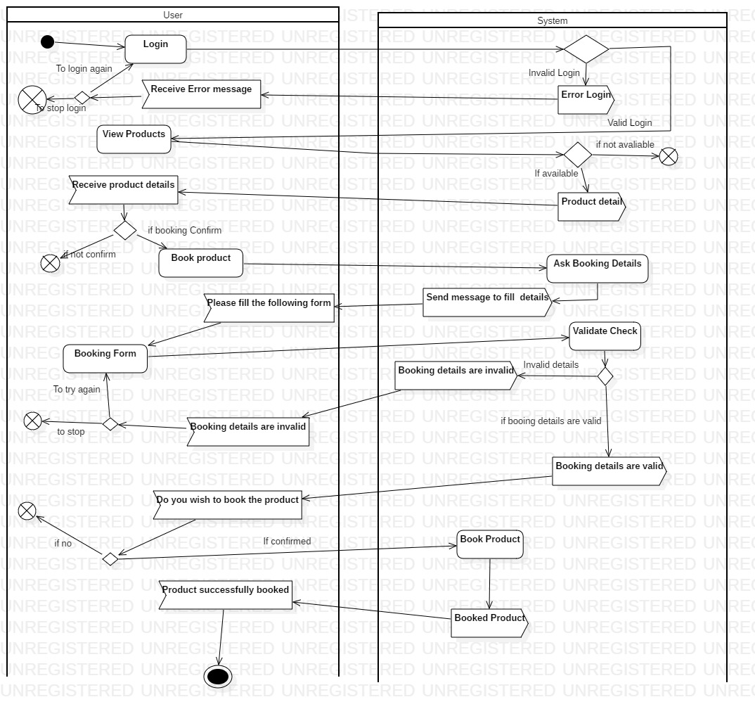

Figure 5 Product Booking Activity Diagram

The activity begins with user already logged in. The user will proceed to view product which if available will be shown to them. After that the user can make booking of the product and the system will send a booking for. The user fills the booking form and confirms the booking. If every details are valid in the database, the system will send a message of successful booking and the activity will end.

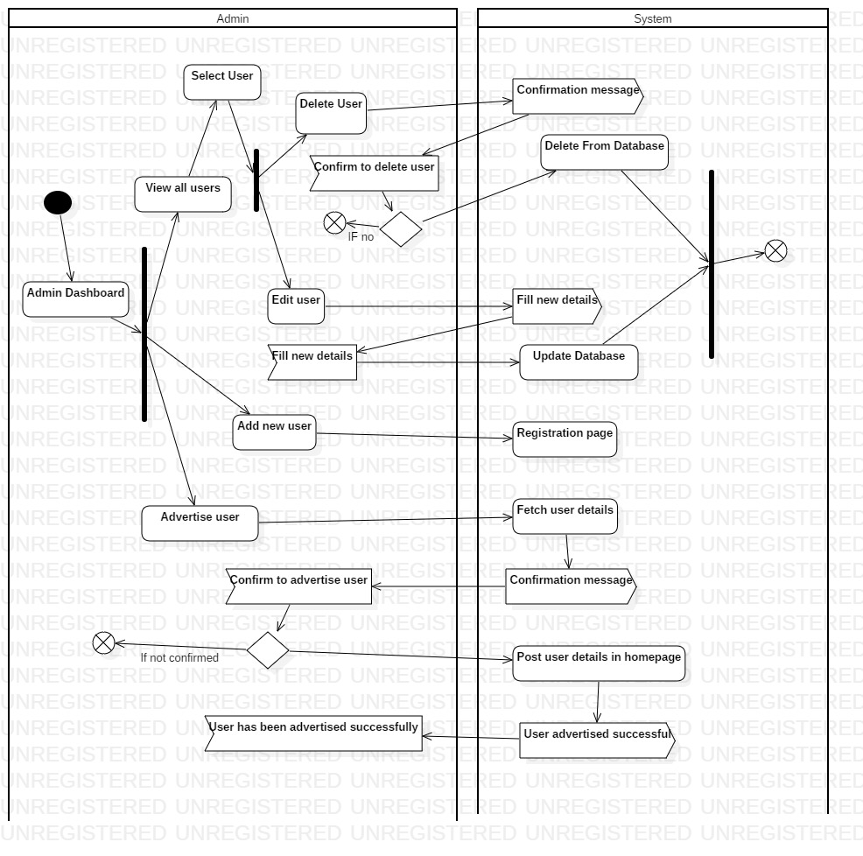

Figure 6 Admin Dashboard Activity Diagram

Admin can perform different actions in the admin dashboard as shown by the fork notation. In summarized way, the admin can manipulate user details by asking permission from the system and confirming the manipulation will allow the system to manipulate the user data in the database. Each complete manipulation will end the flow of action as shown by the join notation. The admin can also advertise users by fetching the user details from the system and confirming will allow the system to post some part of the user details in user’s homepage.

### **Sequence Diagrams**

The diagram used to represent the interactions of different classes and objects of a system in a time sequence is known as sequence diagrams. It depicts the logical flow of the system in a visual manner.

The justification of using sequence diagram in my project are as follows.

* It creates a common ground to help the developers and business analysts understand the system.
* It helps to visualize what will happen during the execution of each use cases created in the project.

**Notations**

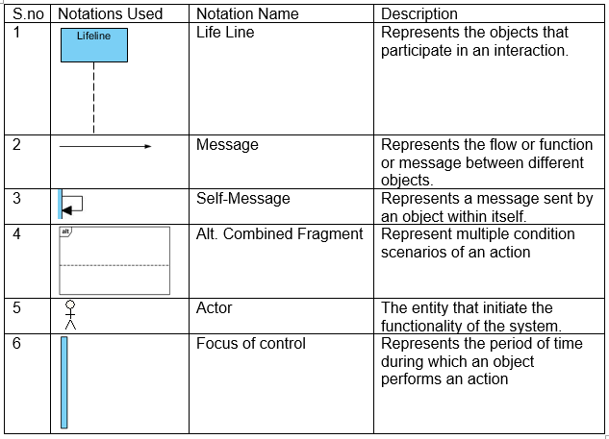

The sequence diagram for my project is given below.

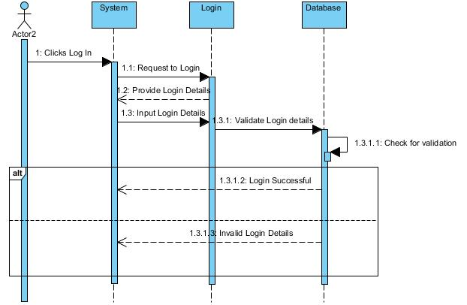

Figure 7 Login Sequence Diagram

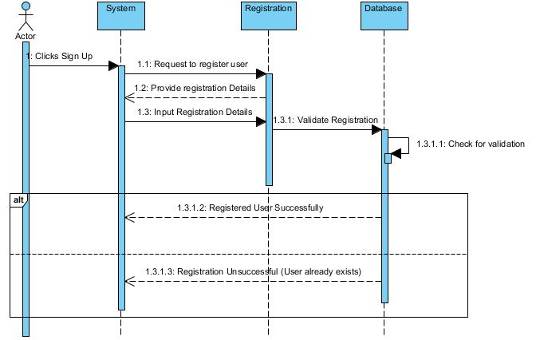

The users start the action by clicking the login/signup button after which the system will request the login/register page to login/register. The page will send a form to the system to fill the details. The user fills the details in the system and the system will send it to the page. The details will them be sent to be validated in the database. The database will check for its validation within itself. If the details are correct, a message of successful login/registration will be sent to the system, else a message of invalid login/registration details will be sent.

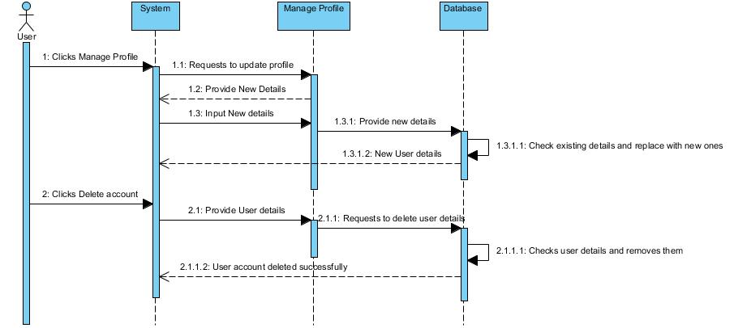

Figure 8 Sequence Diagram to manipulate profile

The user starts the action by clicking manage profile/delete account. The system requests the action to the respective page and the page will send a form to fill new details After filling the details, the page will send it to database which I turn checks for the old details and updates/delete them. A message will be sent to the system that the action has been performed successfully.

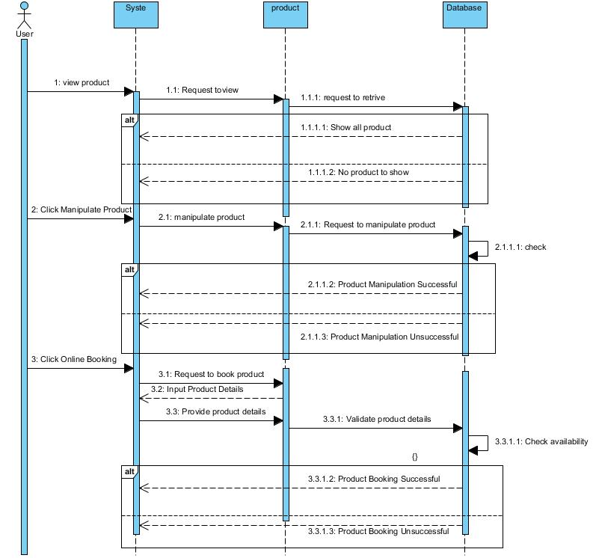

Figure 9 Sequence Diagram User Action

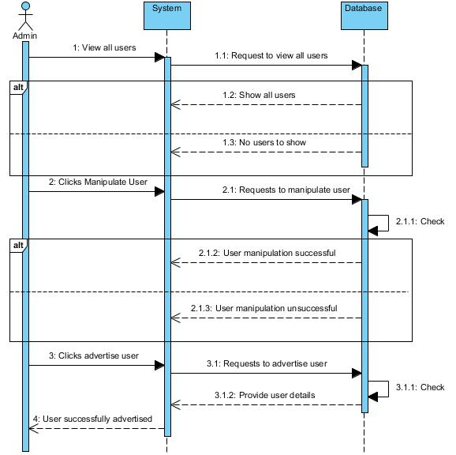

Figure 10 Sequence Diagram Admin action

Each action performed by the user/admin will be requested by the system to the particular page. If details are required, the page will send a form to fill details back to the system. The system sends the filled form to the page and the page sends it to the database. The database then checks the details within itself and carries out the required function. If the action is successful, a message of successful action will be sent to the system. Else a message of unsuccessful action will be sent.

## **Database Modelling**

A database modelling is the process of representation of data in a manner in which they are fundamentally stored, organized as well as manipulated so as to provide the logical structure of a database. One of the popular type of database modelling is a relational database modelling which makes use of a table format for data.

### **Data Dictionary**

A data dictionary can be defined as a set of information used to describe the structure, contents of the database as well as the format it is made upon. It also represents the relationship of the different elements and helps in the manipulation of the database.

The justification for using a data dictionary for my project are

* It helps to manage all the important details that my project goes through i.e. user details, admin details, product details etc.
* It gives a common meaning to different elements of my project which is easy to understand.
* It helps to analyze the characteristics of my project from a foundation level which helps to locate errors easily and make changes in a comparatively efficient way.

Below are the different elements of my data dictionary.

Admin Registration Table

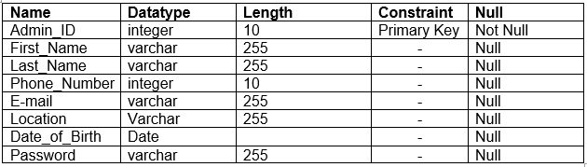

User Registration Table

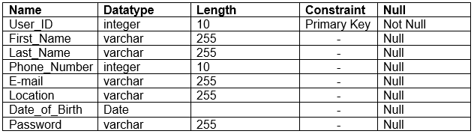

Online_Booking Table

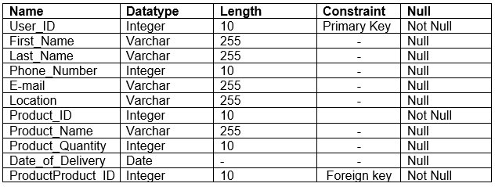

User_Online_Booking

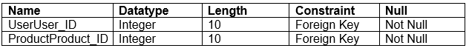

Product Table

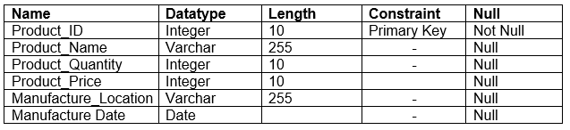

Community Forum Questions Table

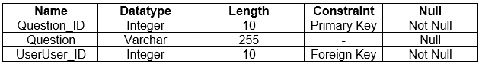

Community Forum Answers Table

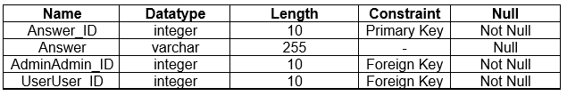

Product Feedback Table

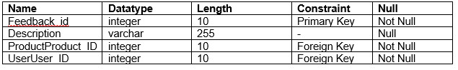

### **Entity Relationship Diagram**

An entity relationship diagram (**ER Diagram**) is a diagrammatic or graphical representation of different entities and their relationship between each other which is used for organizing data in a database. Each entities holds attributes and their individual data types and are related by different types of relationship like one to one, one to many and many to many.

The justification for using the entity relationship diagram in my project are.

* It acts as a blueprint for the database of my project which helps to create a documentation used to understand the core of my database.
* It helps in the design process to create a format of my database before even creating my database tables.
* It helps to communicate the logical structure of my database and helps the users to organize data.

The ER diagram for my project is given below.

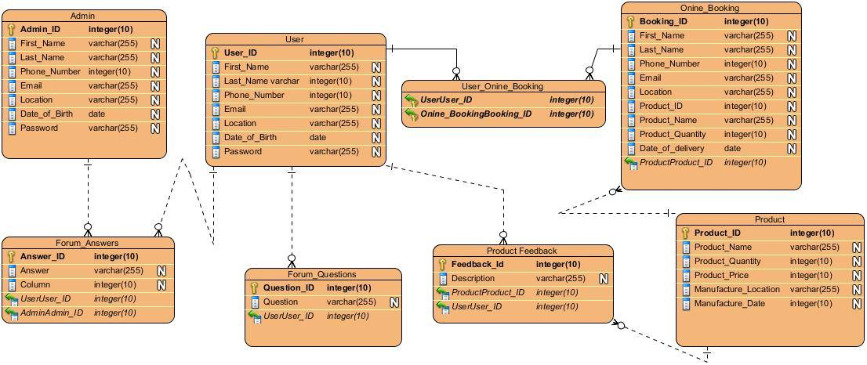

Figure 11 ER Diagram

## **Architectural Model**

The architecture model used for my project is client server architecture. This model involves the server to control most of the resources and services used by the client. This architecture involves one or more client computers to be connected to a centralized server.

The justifications for using this architectural model in my project are:

* Buyers and sellers (Framers and manufacturers) have a distinct task to routinely perform in my project and the server has its own distinct tasks.
* Management of data is easy. Since all data are stored in a centralized location, finding, recovering and backup of data is easy.
* Necessary changes can be easily done in a centralized server.
* Server can define guideline, security and access rights during its setup and can play different roles for different clients.

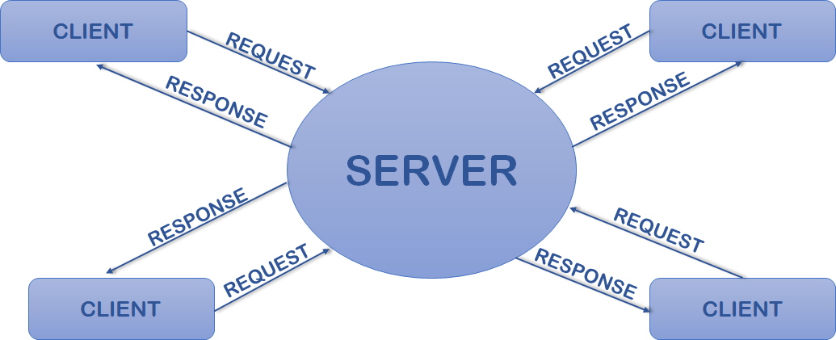

Figure 12 Client Server Architecture

Just like the figure shown above, the clients for my project will be users and admins who will make different requests and the server will respond to those requests. Both users and admins will have distinct tasks and some common tasks which will be separately handled by the server. User data handling will be easier in a centralized server. The server will only allow the admins to manipulate other user’s data and users to manipulate their own data.

## **Prototyping**

Prototyping is the process of creating a guiding model of a system to test the processes and concept of a system based on which a system is built. Prototyping can be of various types but the type that I am using for my project is mockup prototyping. This type of prototype is helpful only for the visual concept of the system and does not include the processes involved.

Balsamiq mockup tool is used for creating prototypes for my project. The mockups prototypes of project IlamTeaGarden is presented below.

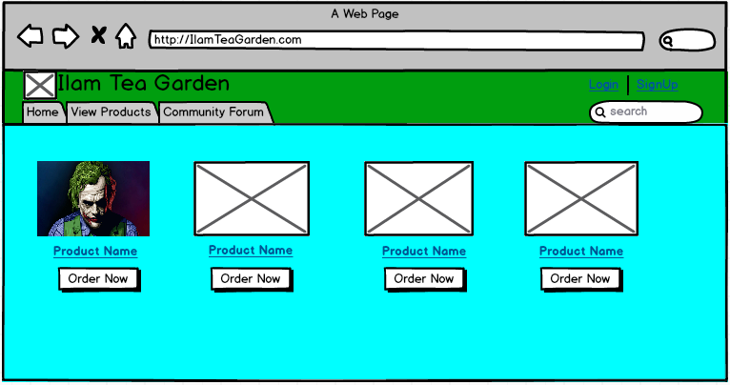

Figure 13 Homepage

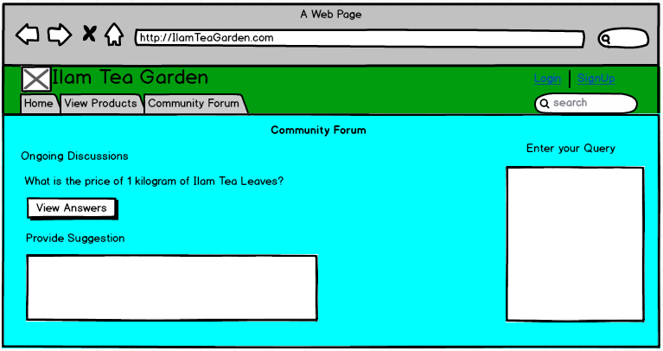

Figure 14 Community Forum

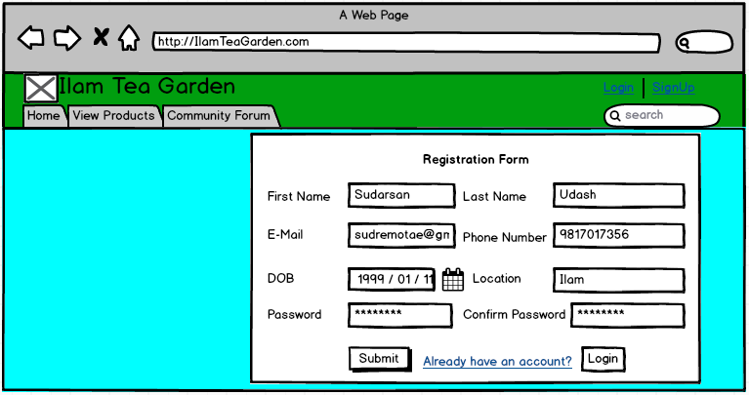

Figure 15 Registration

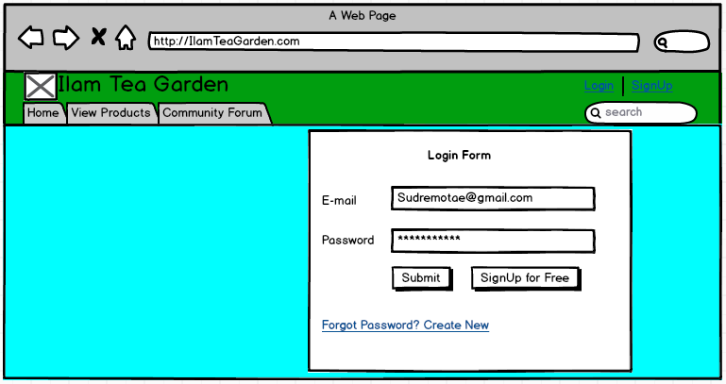

Figure 16 Login

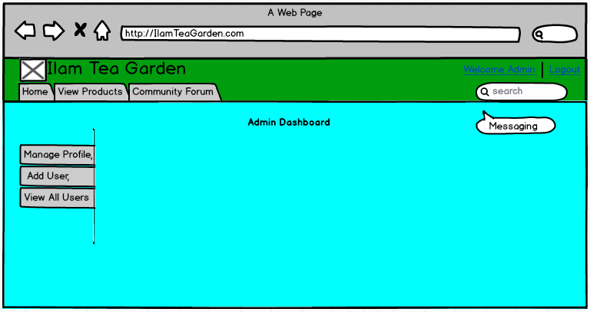

Figure 17Admin Dashboard

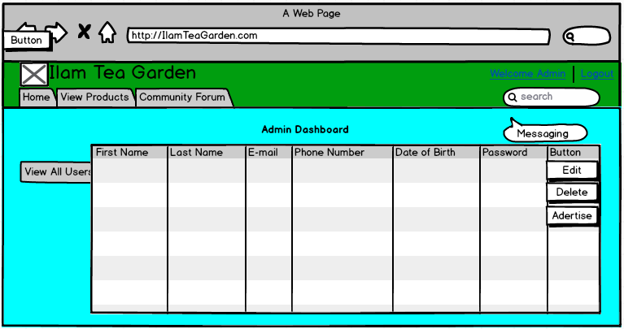

Figure 18 Admin view all users

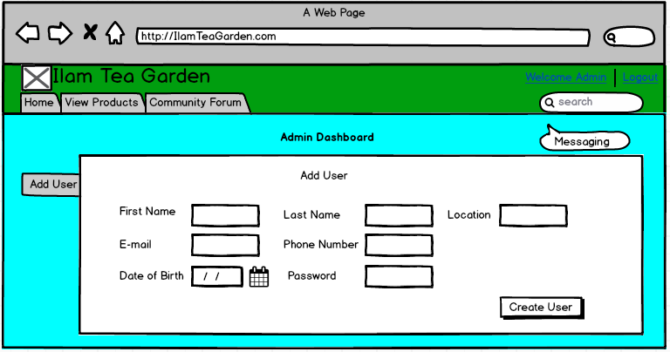

Figure 19 Admin add users

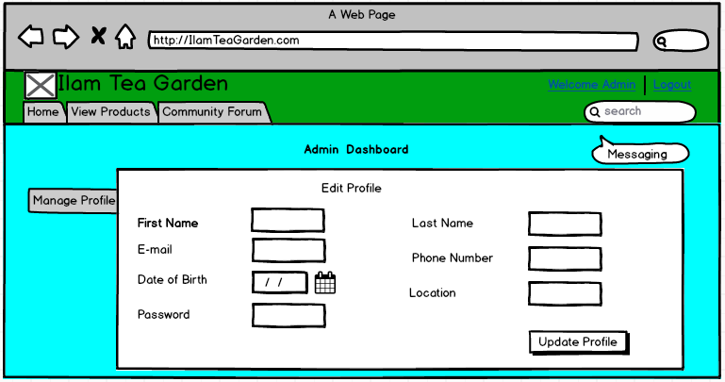

Figure 20 Admin Manage Profile

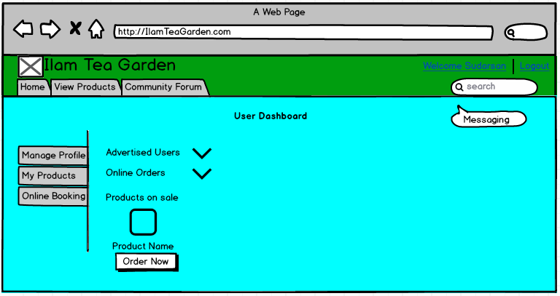

Figure 21User Dashboard

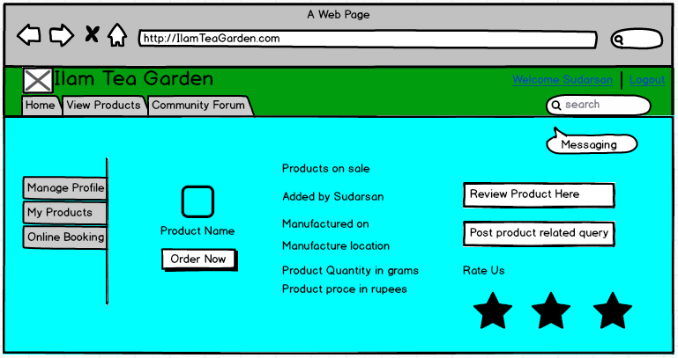

Figure 22 Product page

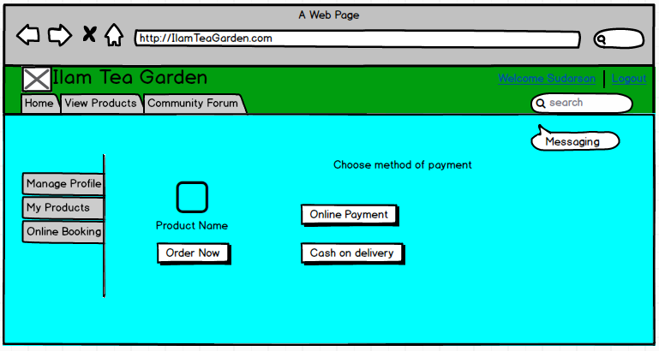

Figure 23 Payment type

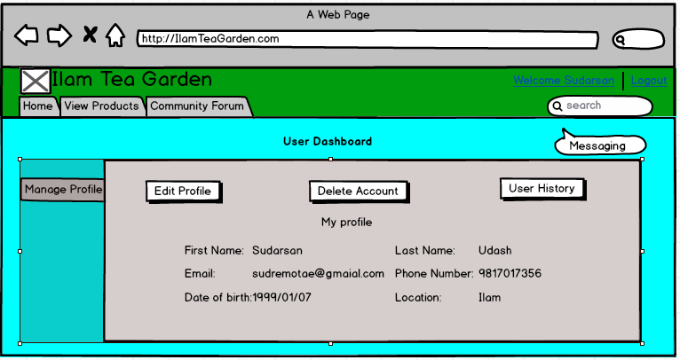

Figure 24 User Manage Profile

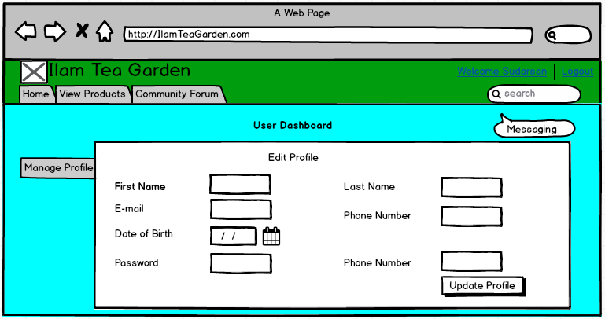

Figure 25 User edit profile

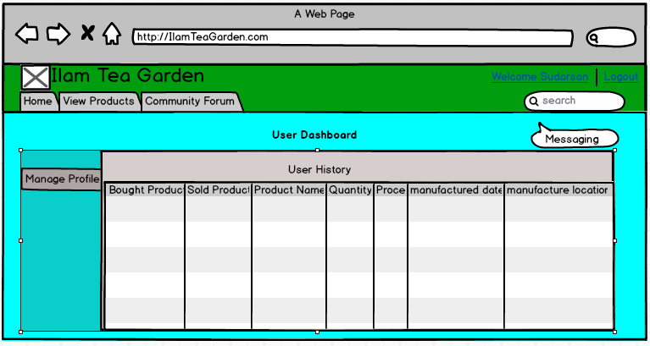

Figure 26 User History

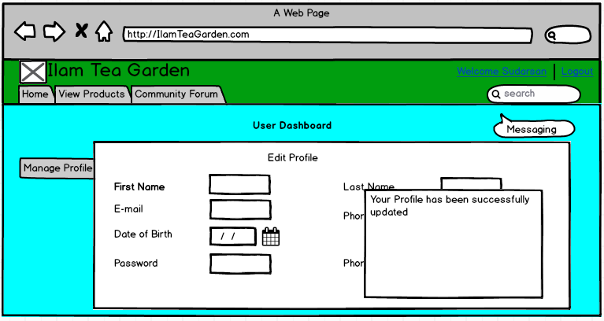

Figure 27 Update successful

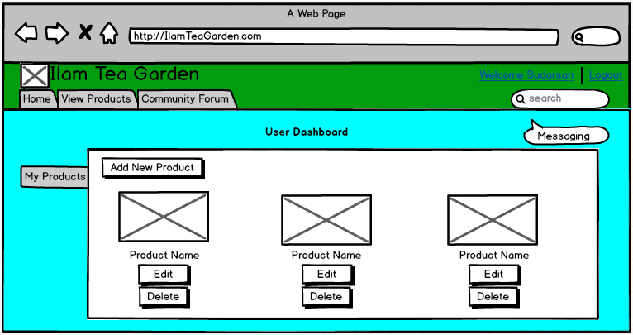

Figure 28 My products

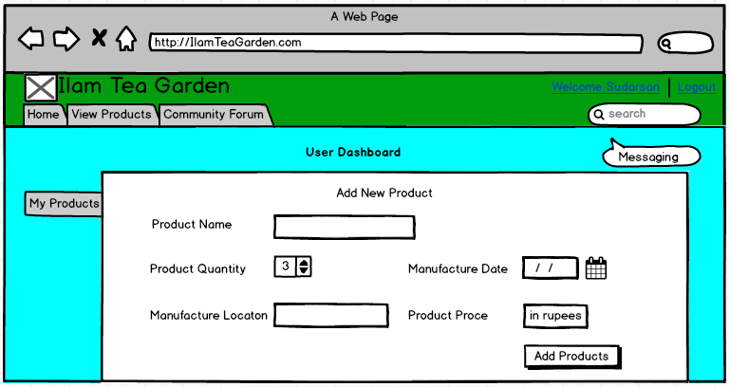

Figure 29 Add new product

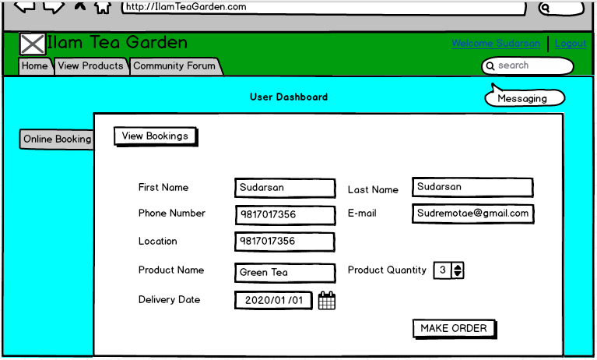

Figure 30 Product Booking

# **Chapter 4: Implementation of Ilam Tea Garden**

Implementation is the process of bringing the previously analyzed and designed project into existence. After proper analysis and design have been completed, the phase of implementation is carried out that usually involves coding and integrating using several tools and techniques.

## **Language Used**

The programming language that I used for my project is Object Oriented PHP (Hypertext PreProcessor) This programming language was designed for web development and the reason for using this language is the same since my project is a web based system.

## **Tools Used**

For the process of implementation, I used the following tools.

* XAMP for running my localhost
* Sublime text for coding
* My SQL for creating a database

## **Snippets of Implementation**

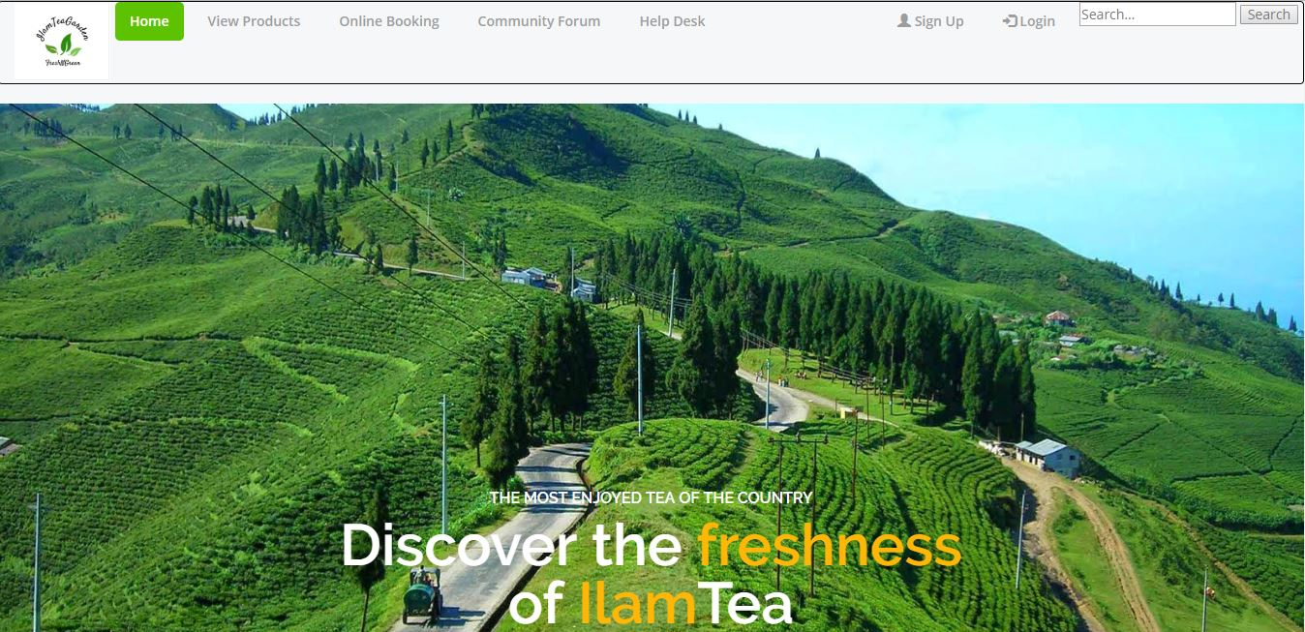

Figure 1 homepage.php

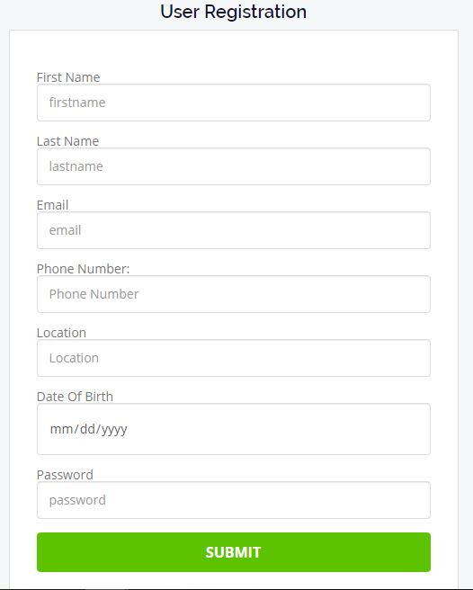

Figure 2 register interface

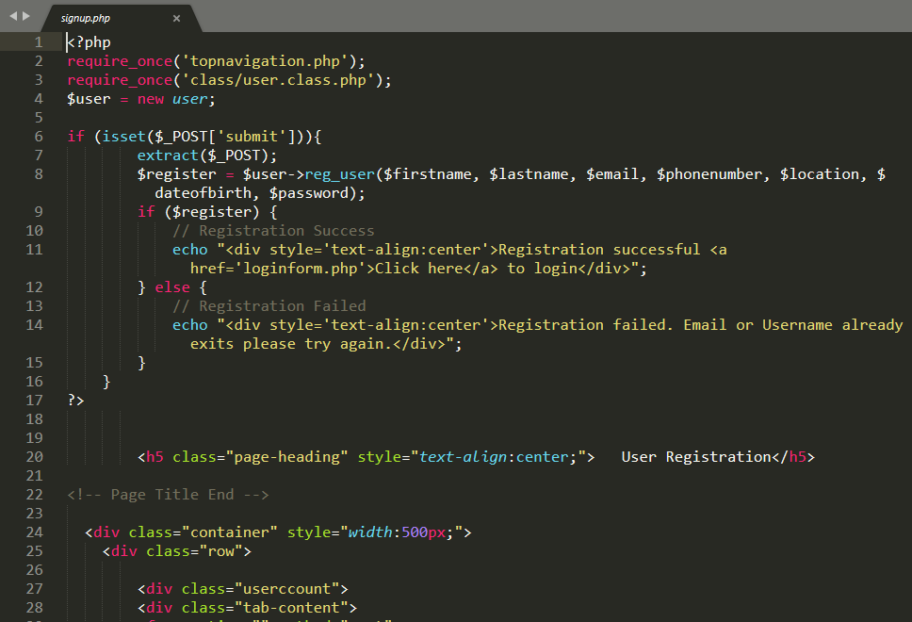

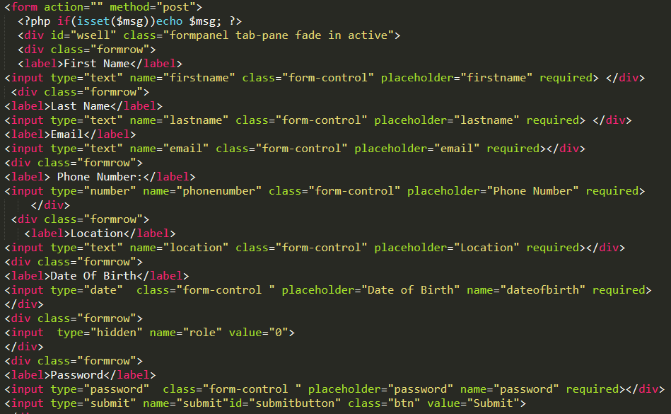

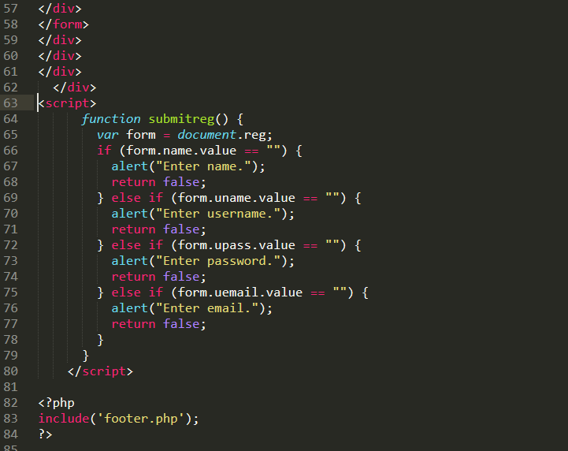

Figure 3 register codes

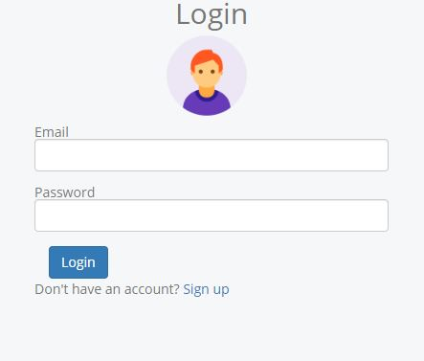

Figure 4 login interface

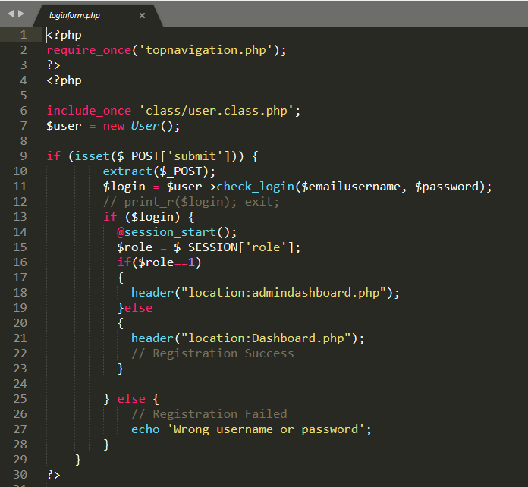

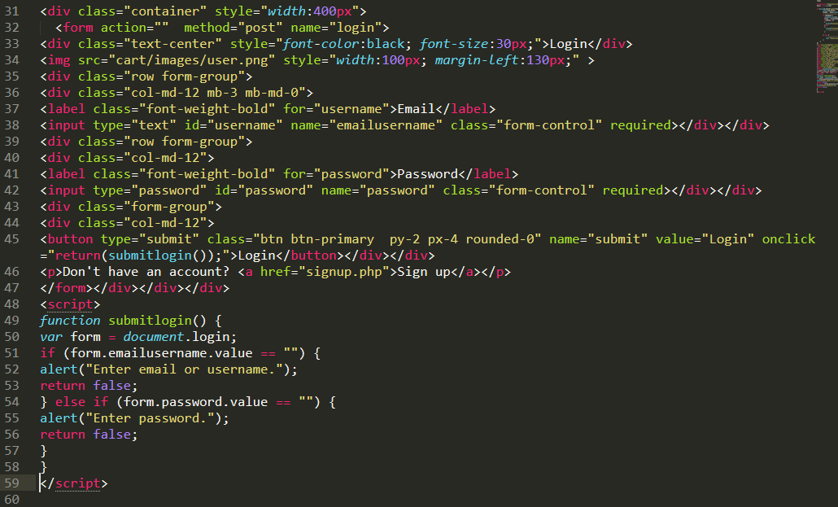

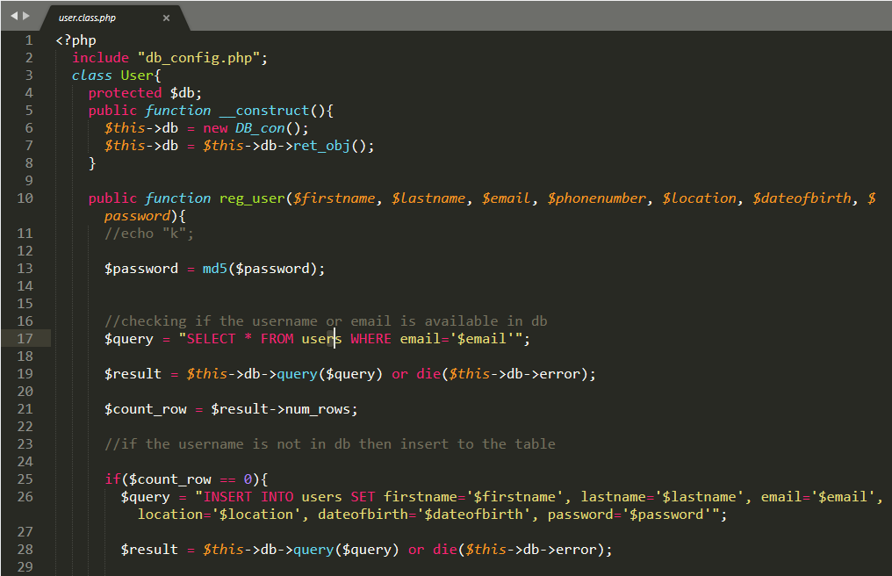

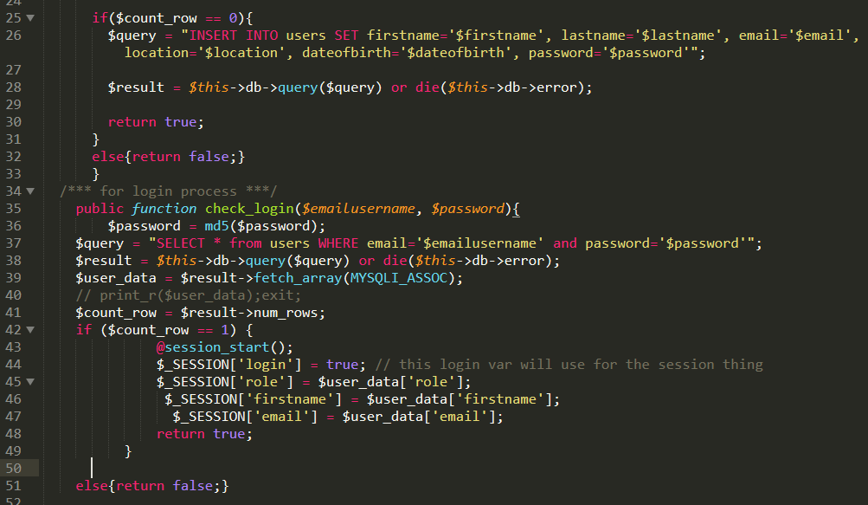

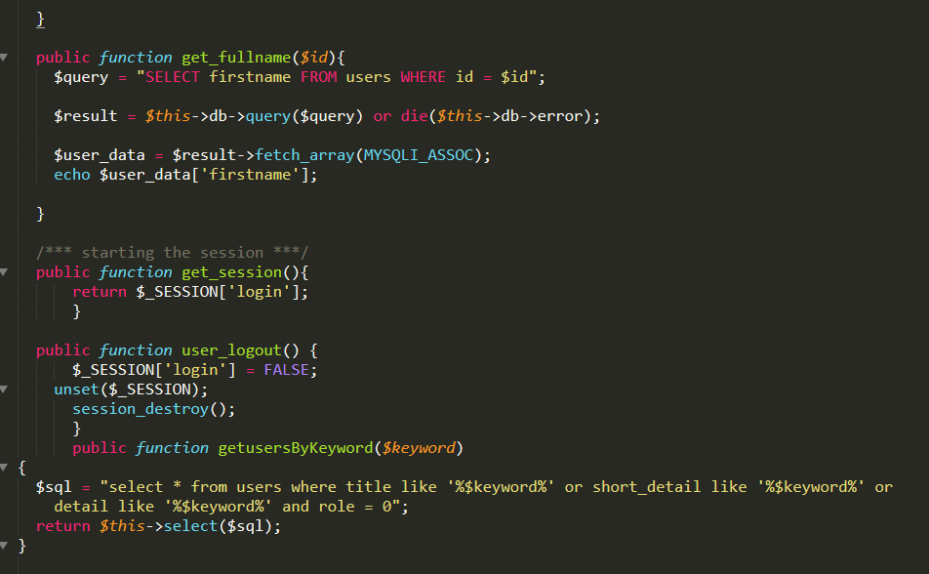

Figure 5 login code

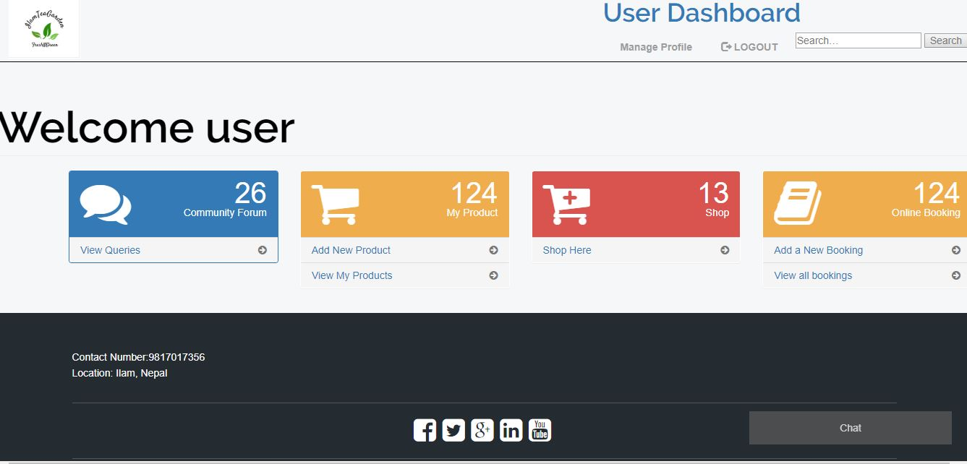

Figure 6 user dashboard interface

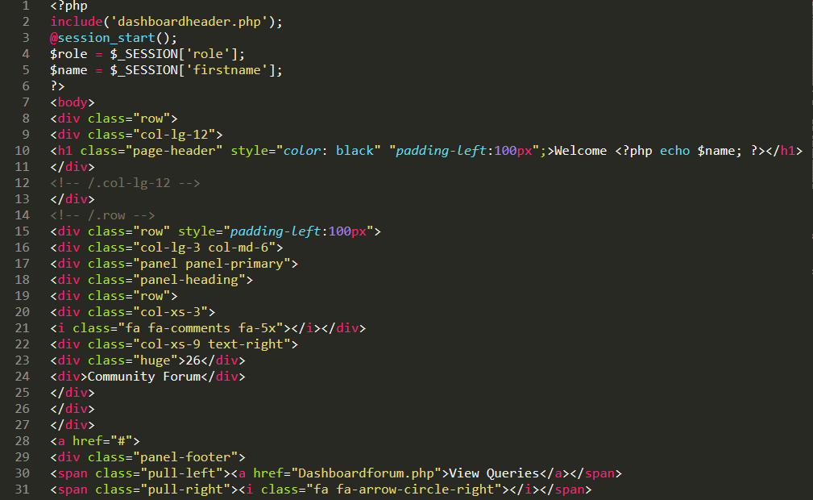

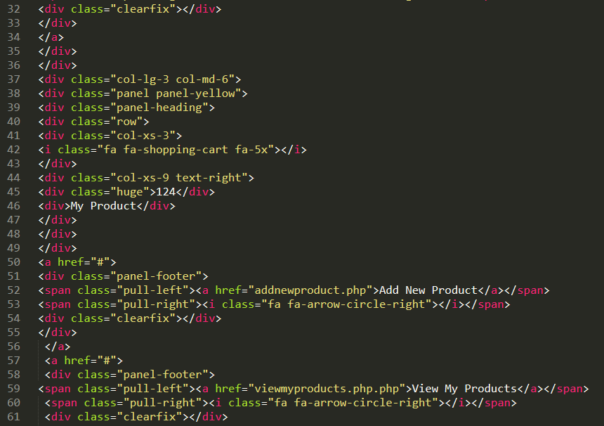

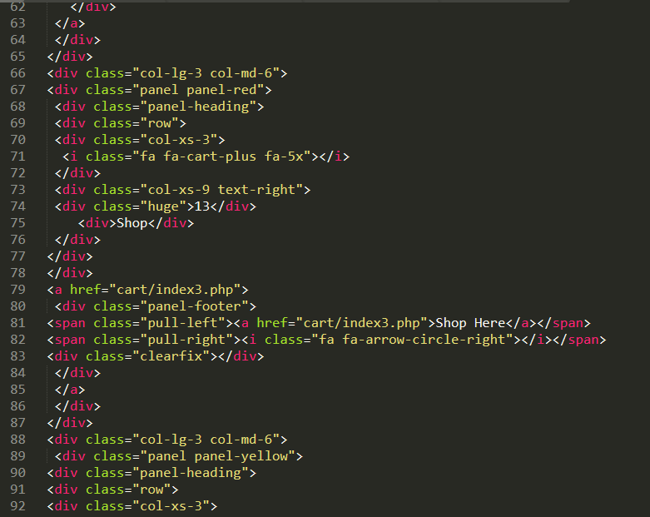

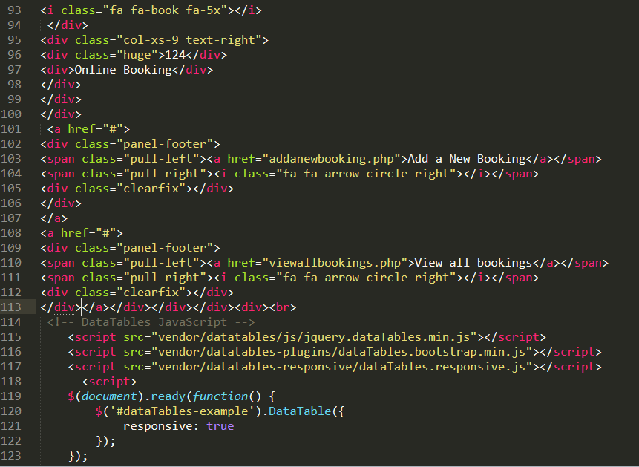

Figure 7 user interface code

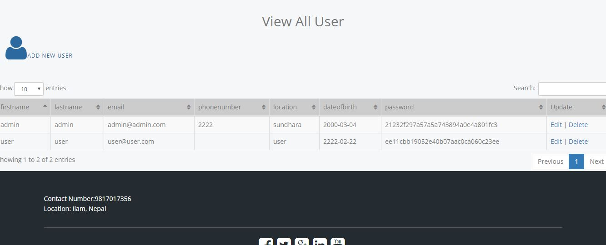

Figure 8 admin view all user interface

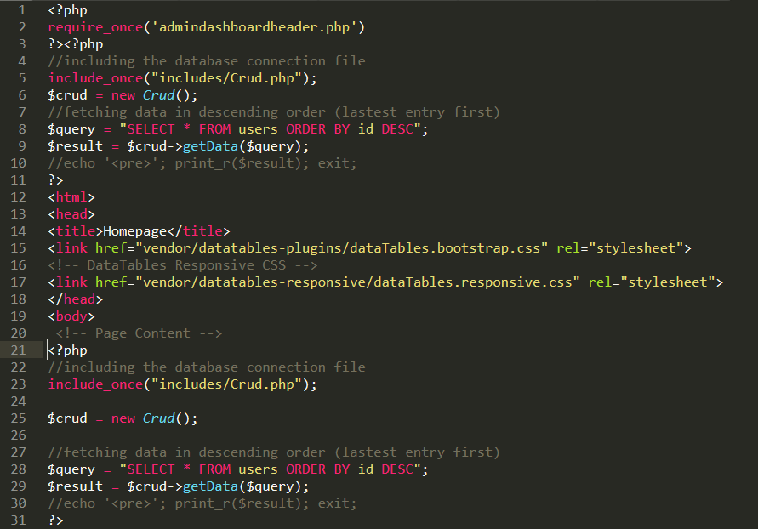

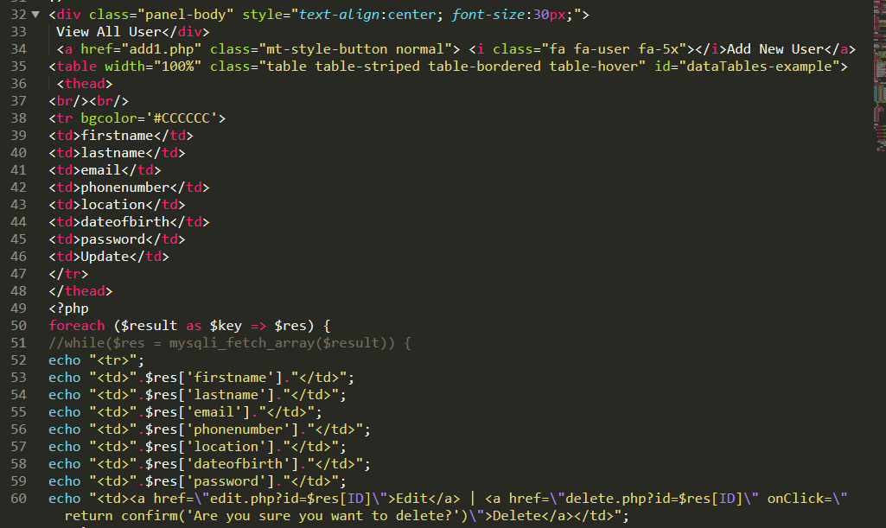

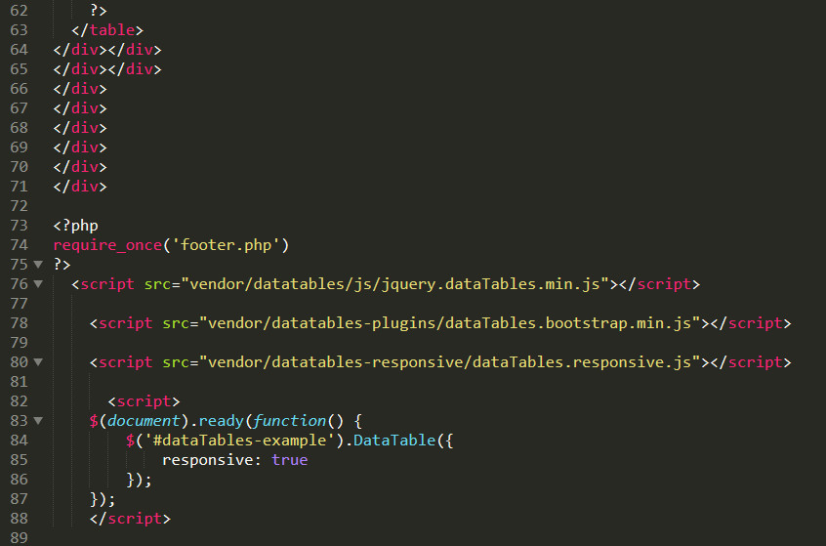

Figure 9 admin view all user codes

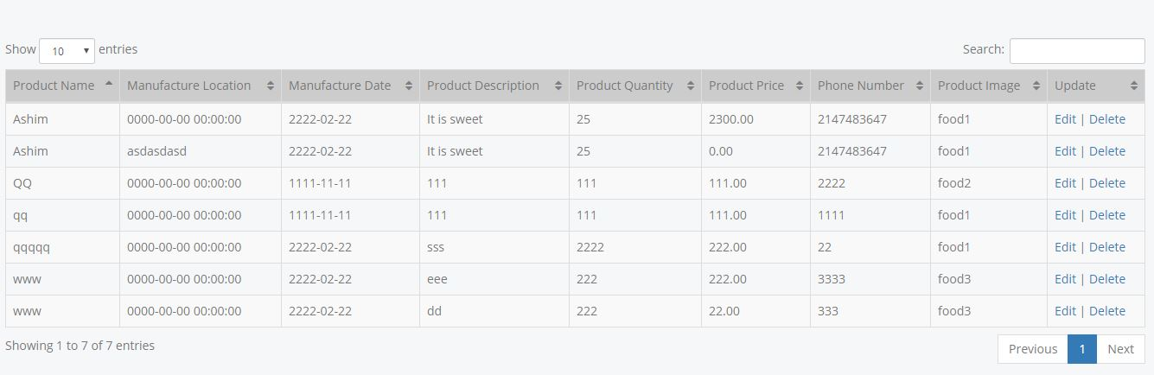

Figure 10 admin view all product table interface

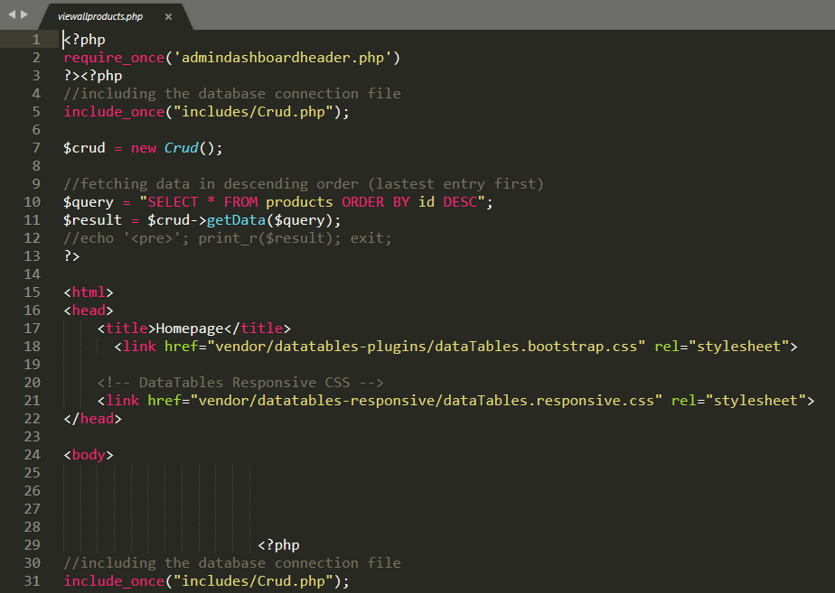

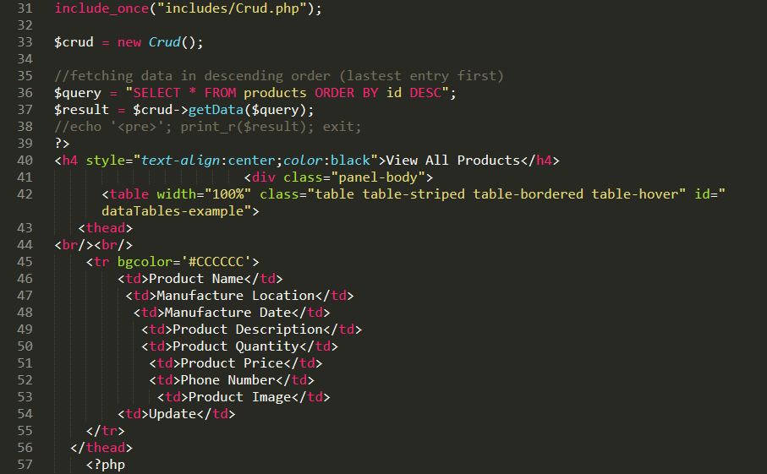

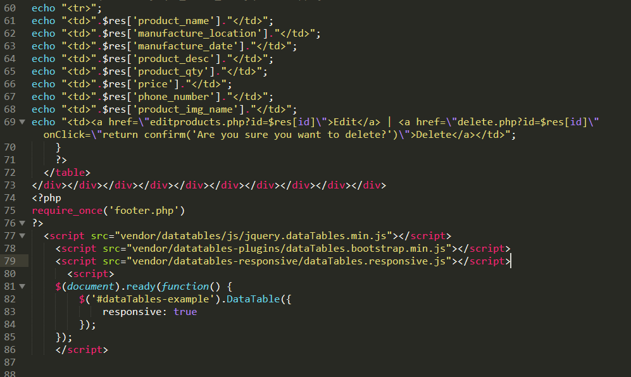

Figure 11 admin view all products code

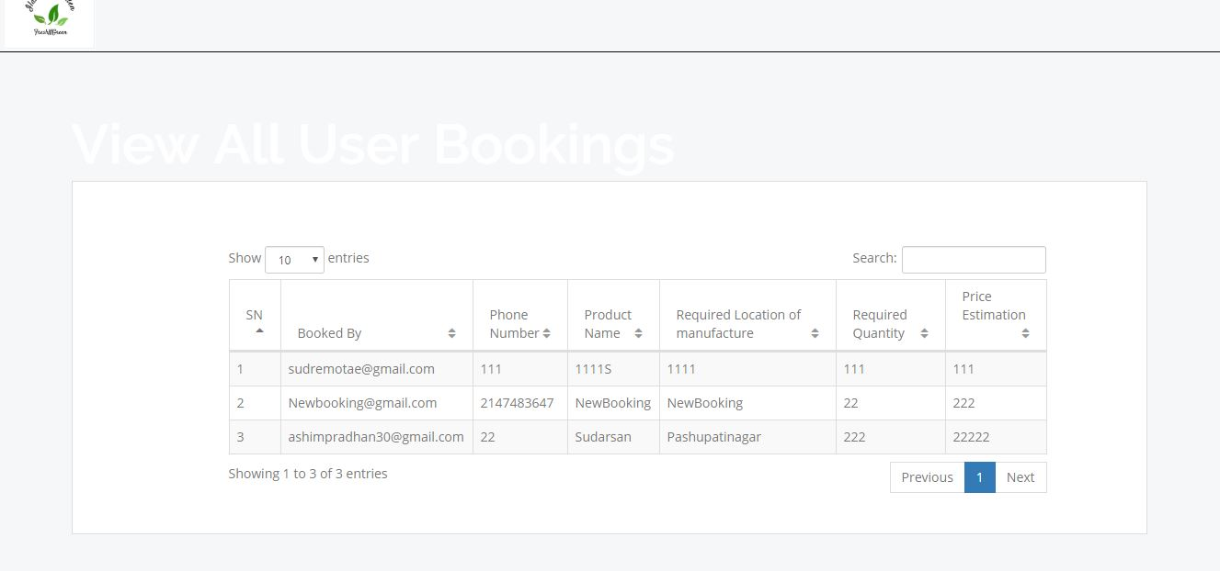

Figure 12 admin view all bookings interface

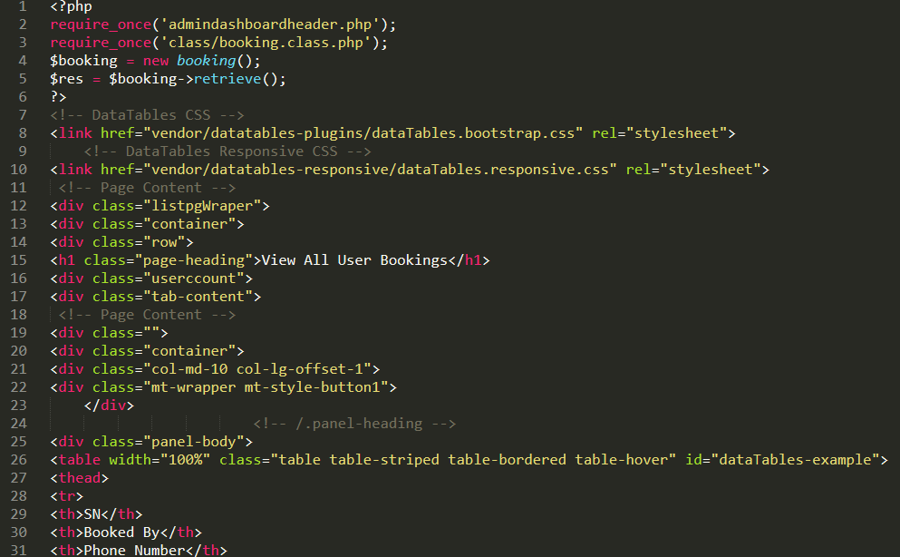

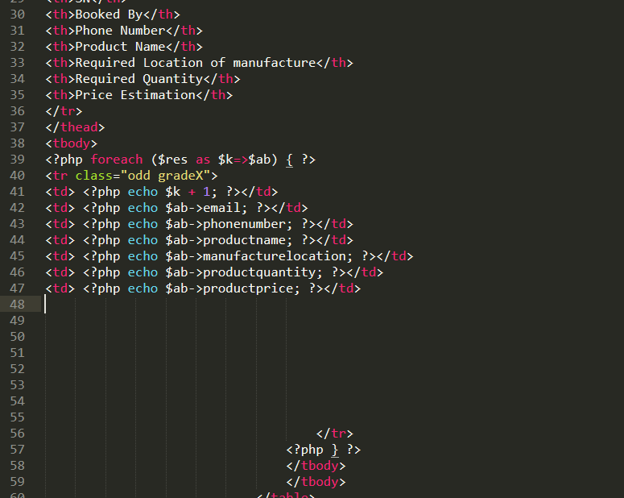

Figure 13 admin view all bookings code

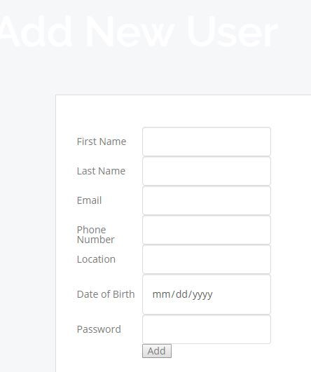

Figure 14 admin add new user interface

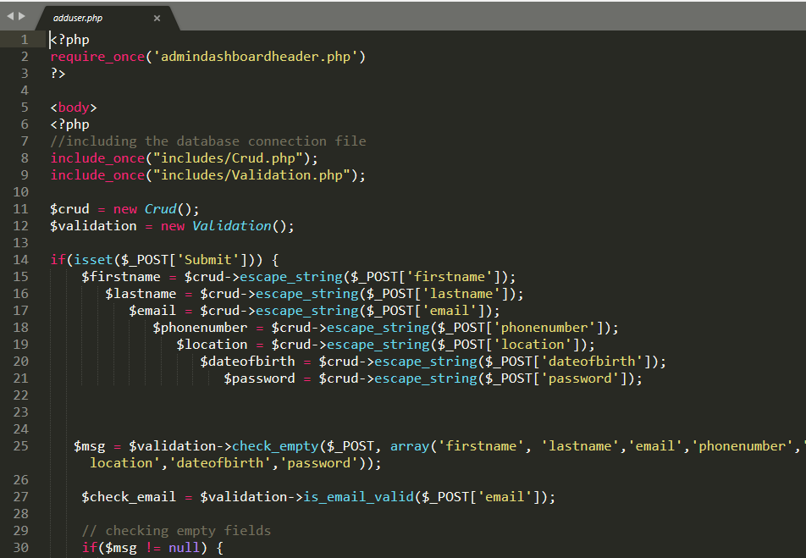

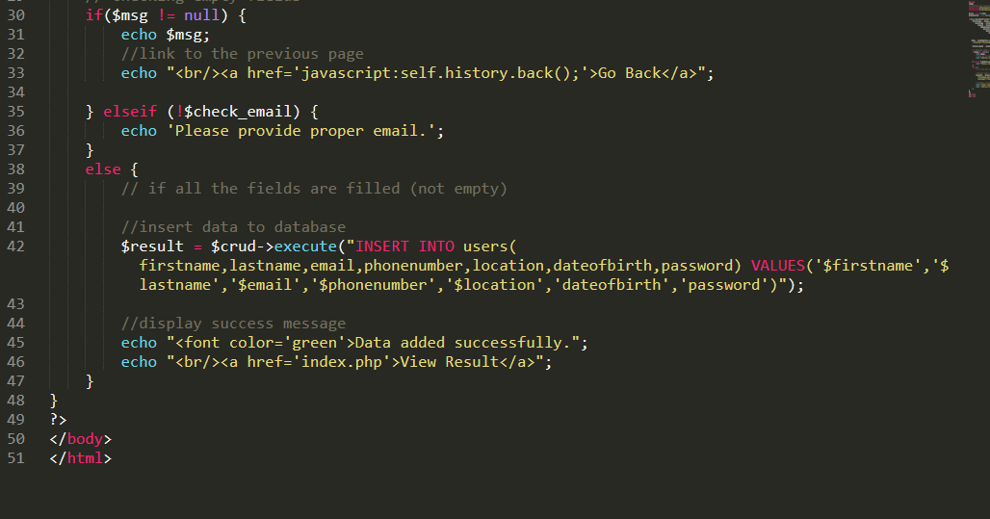

Figure 15 admin add new user codes

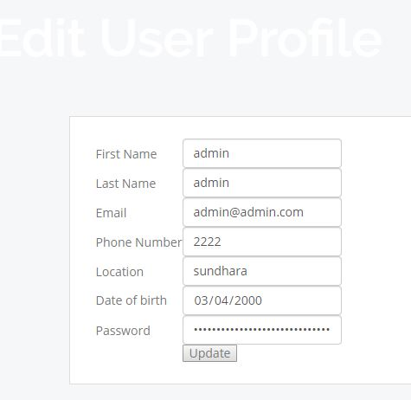

Figure 16 admin edit user details interface

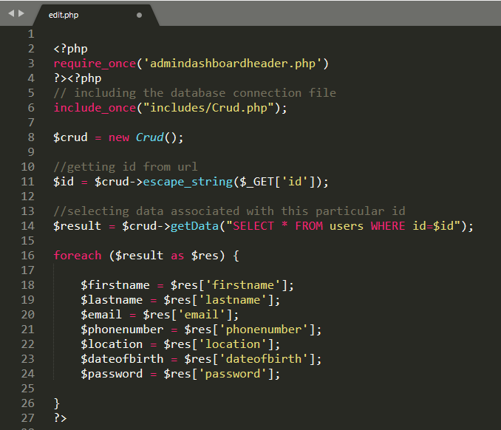

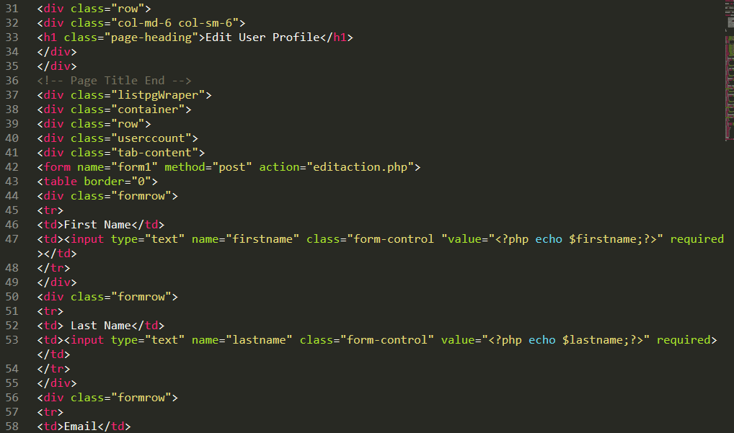

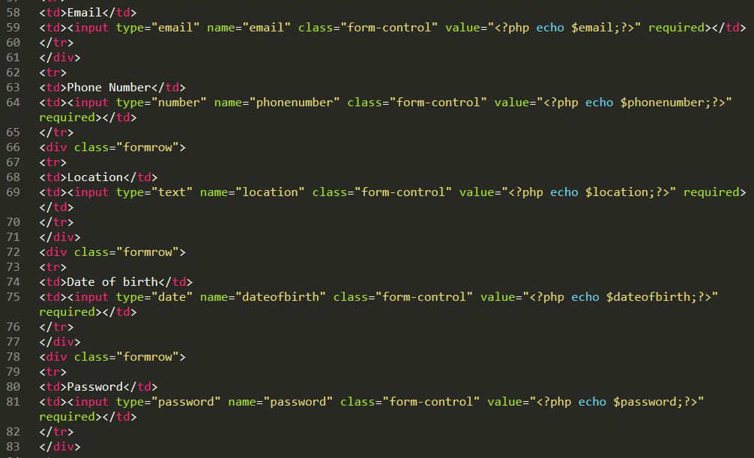

Figure 17 admin edituser code

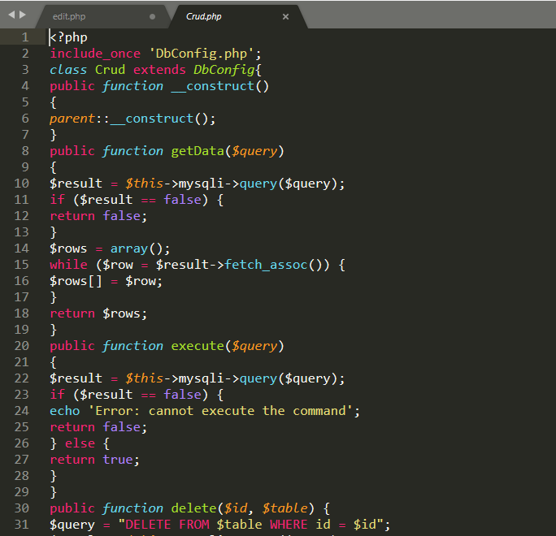

Figure 18 Crud code

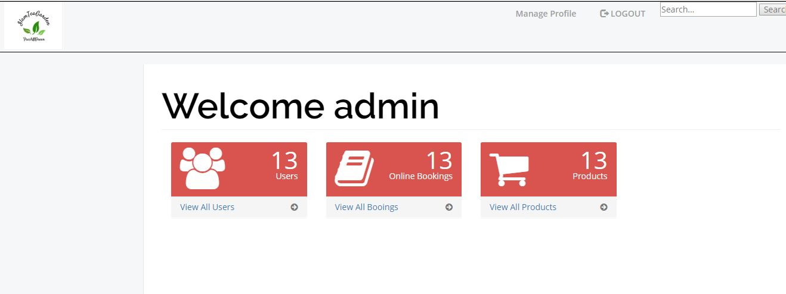

Figure 19 Admin dashboard interface

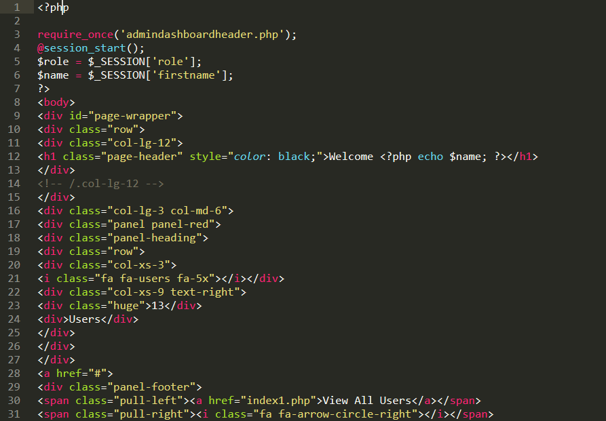

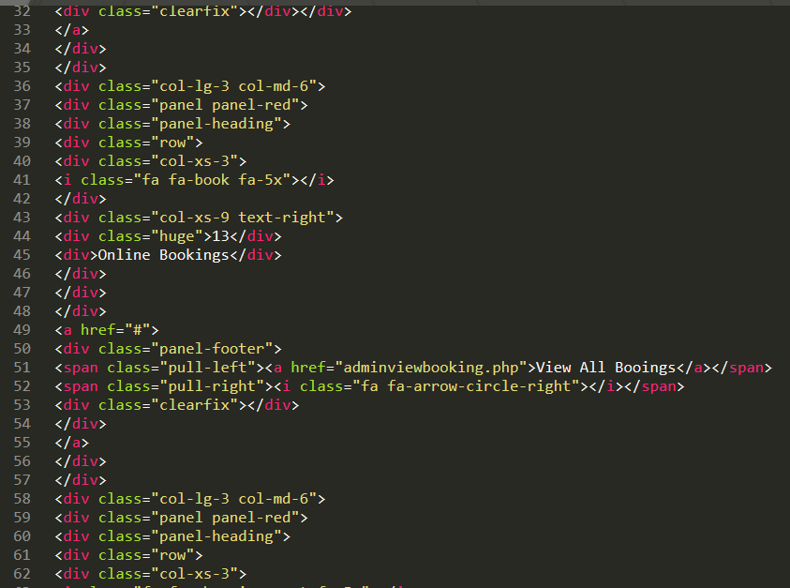

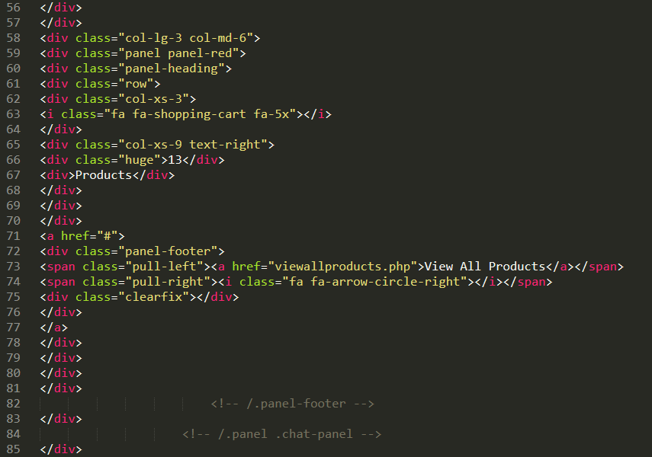

Figure 20 admin dashboard codes

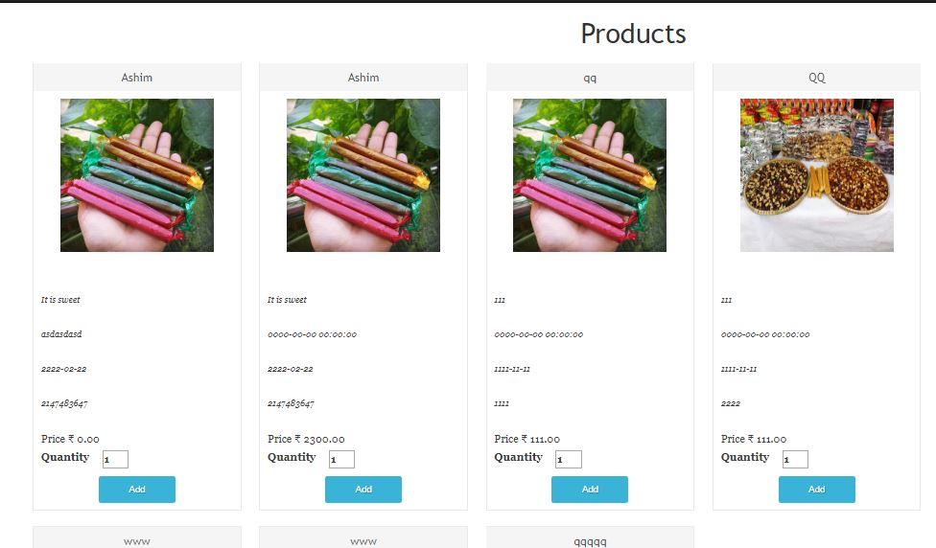

Figure 21 user view shop interface

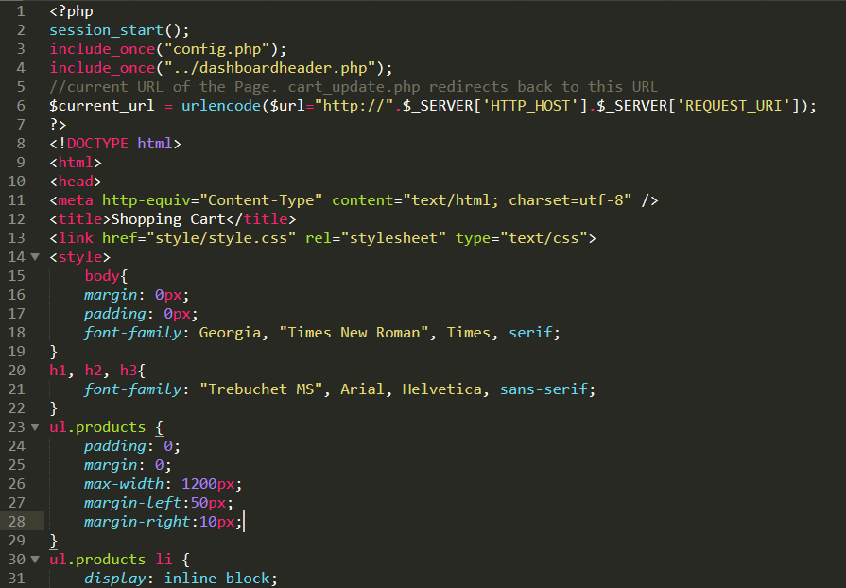

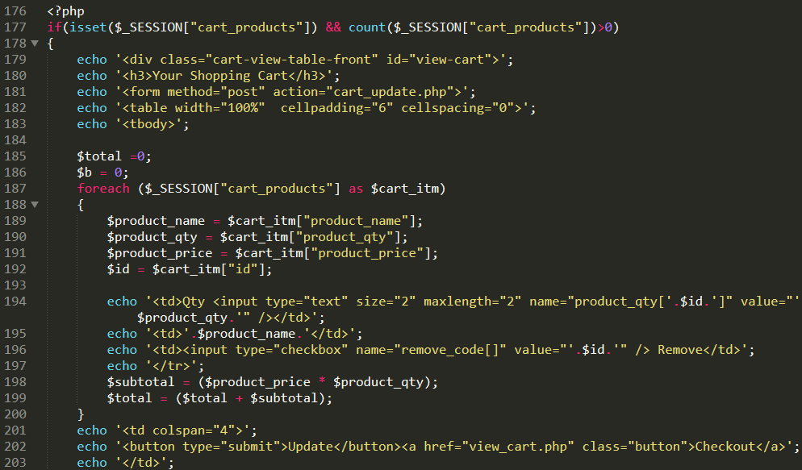

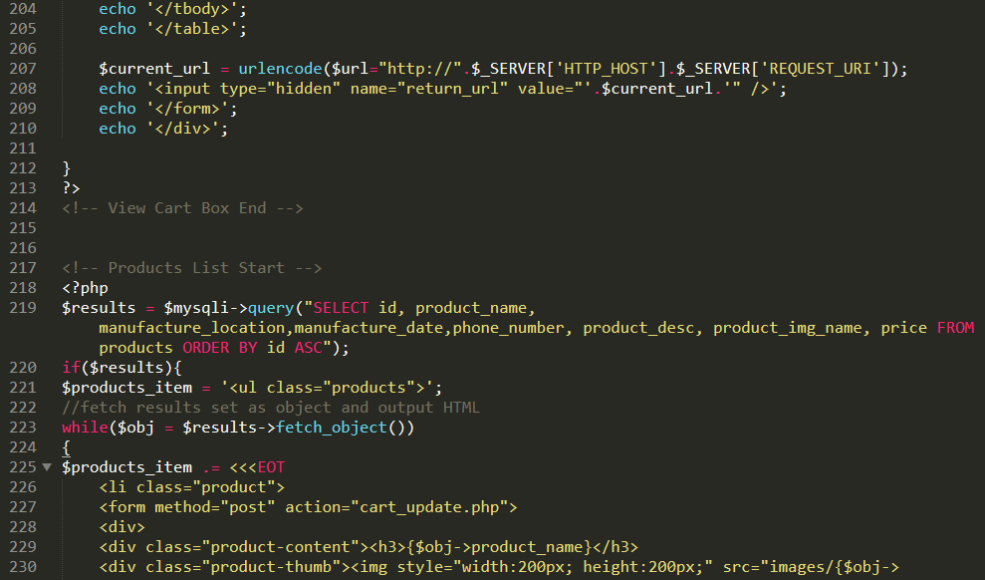

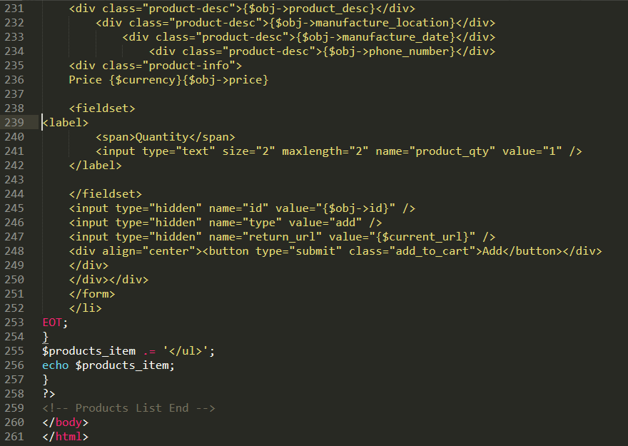

Figure 22 user shop codes

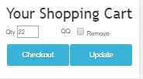

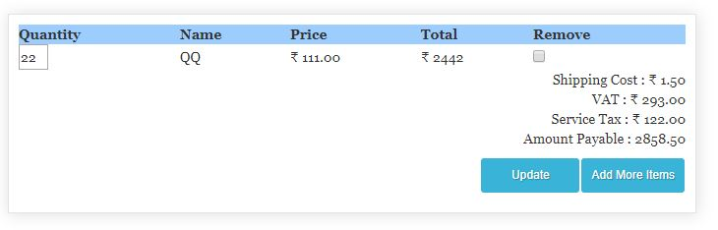

Figure 23 shopping cart interface

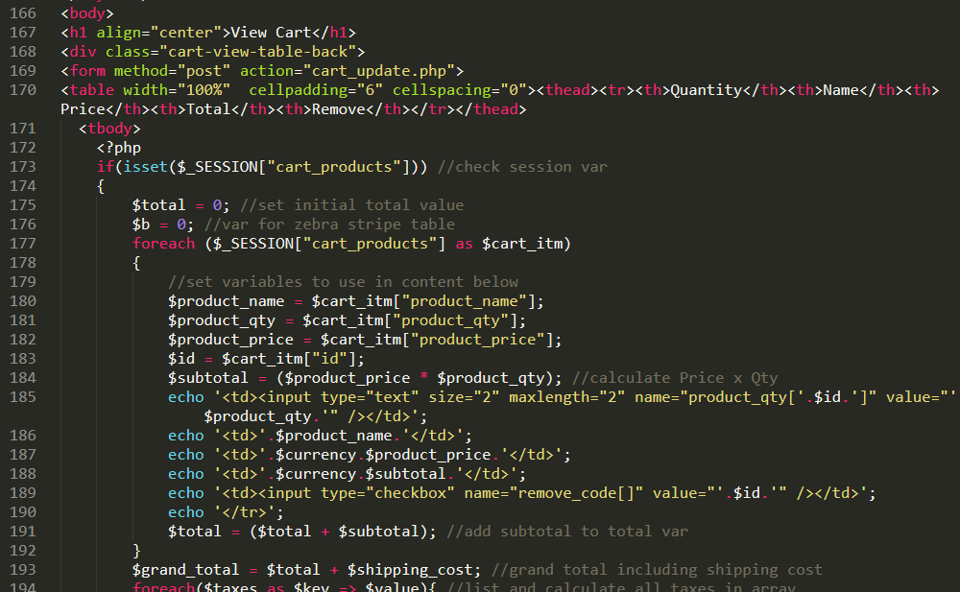

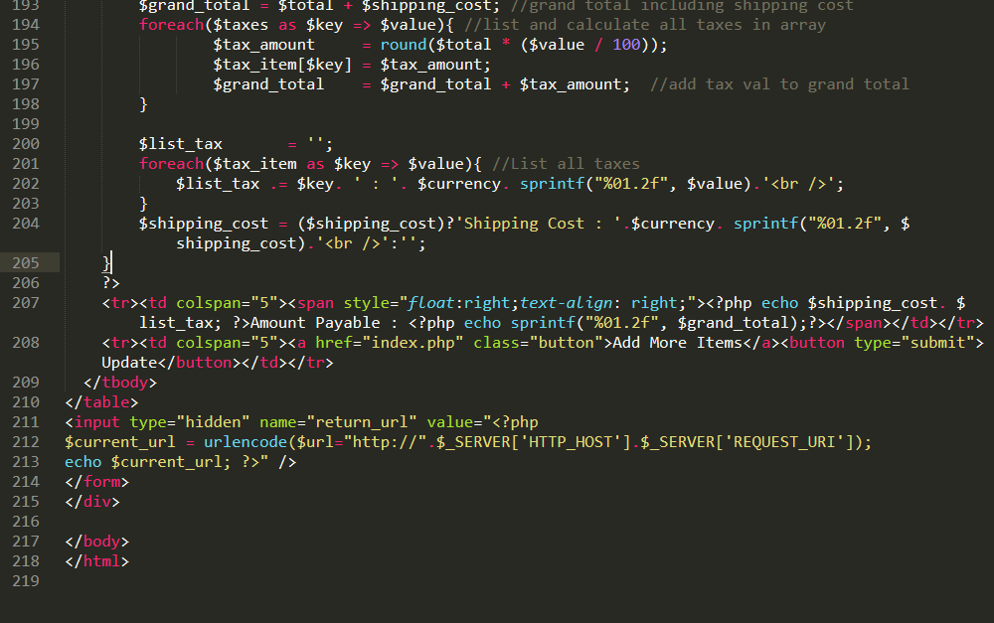

Figure 24 Shopping cart codes

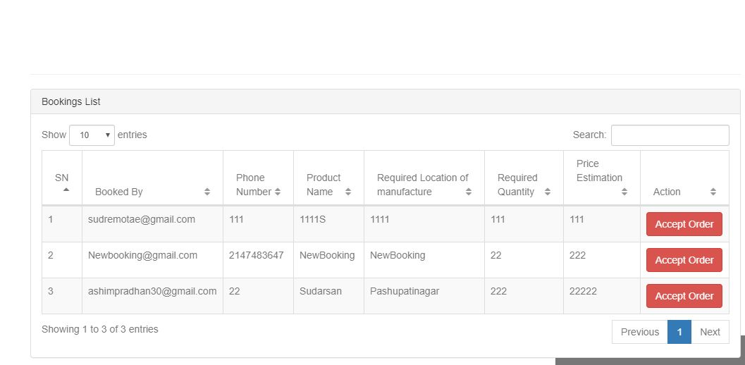

Figure 25 user view all bookings interface

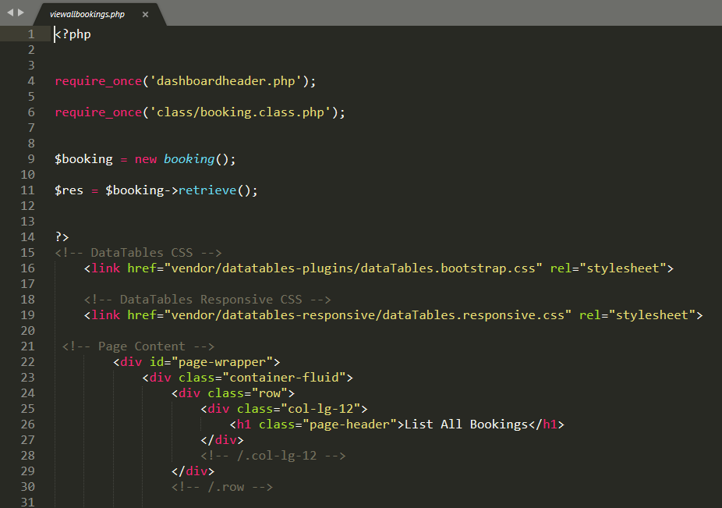

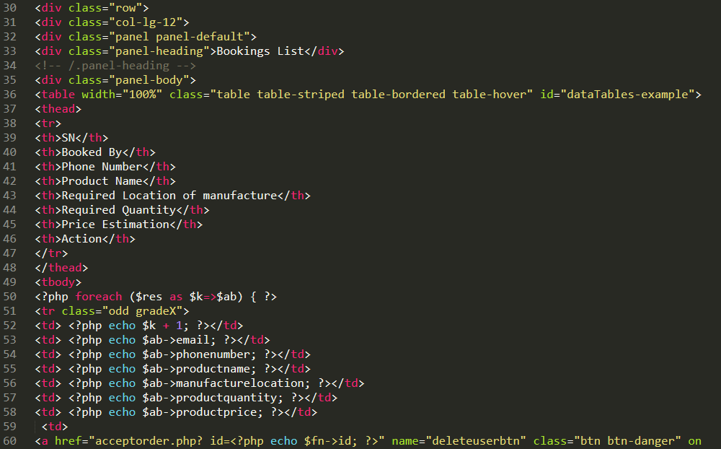

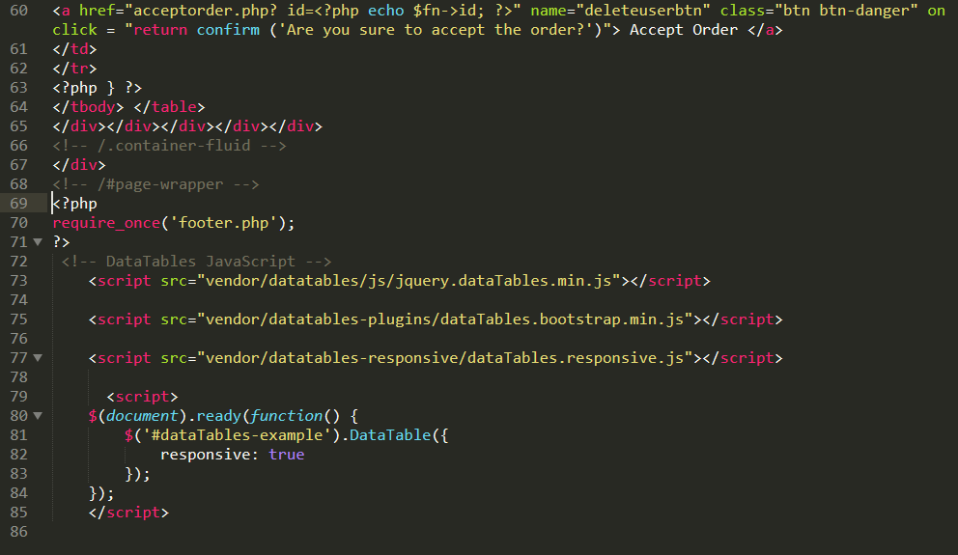

Figure 26 user view all bookings code

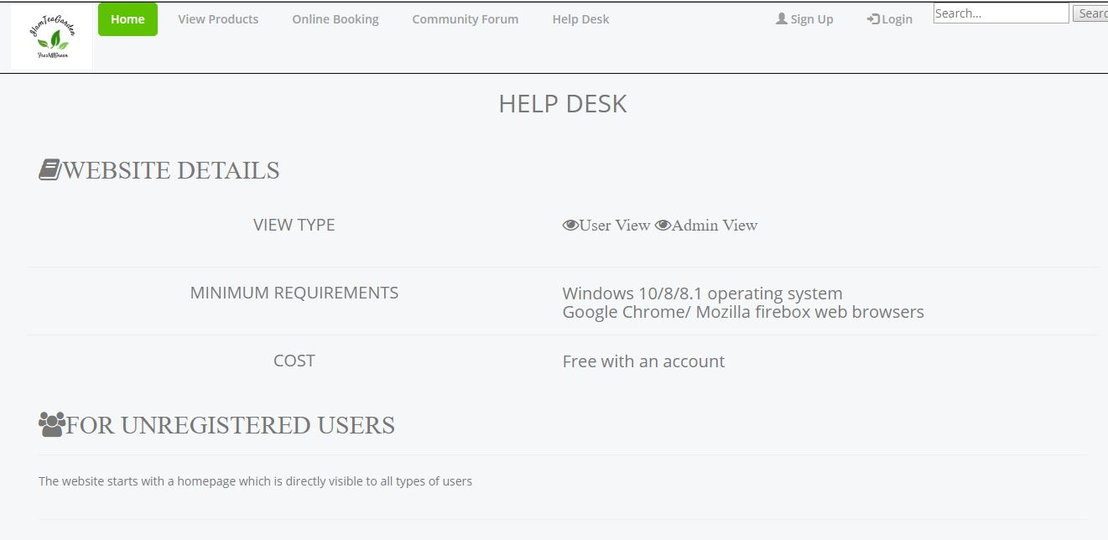

Figure 27 help desk interface

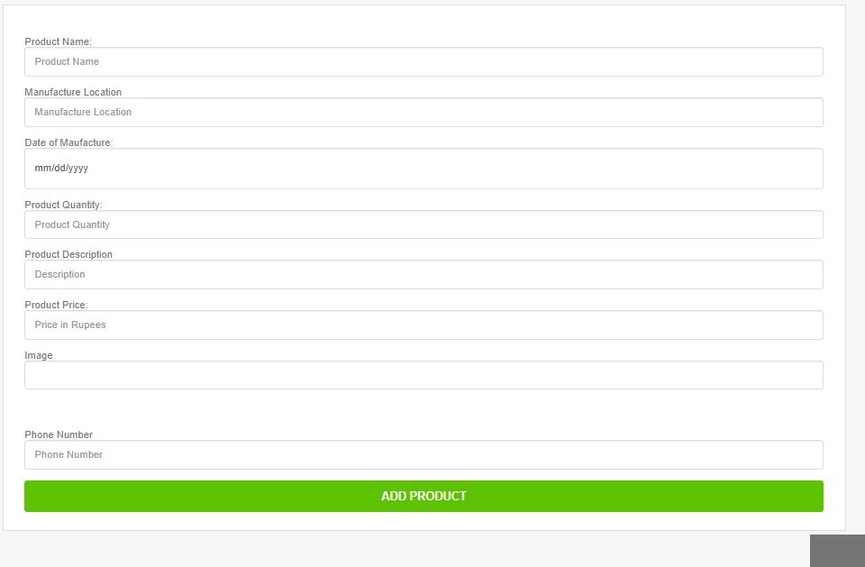

Figure 28 user add new product interface

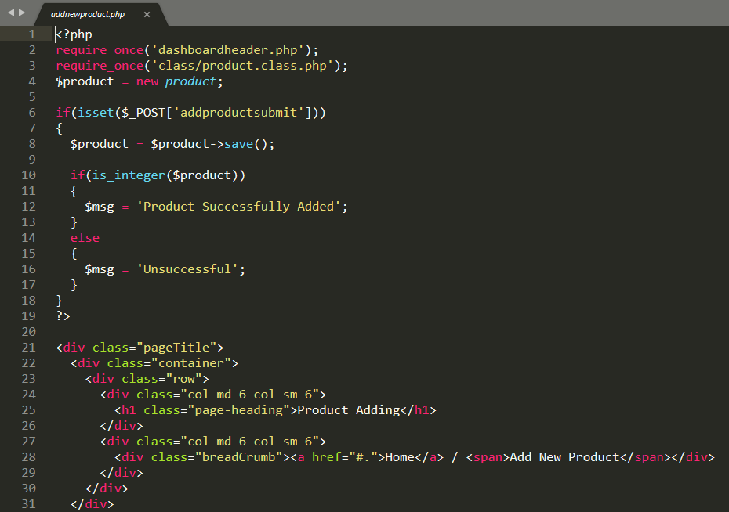

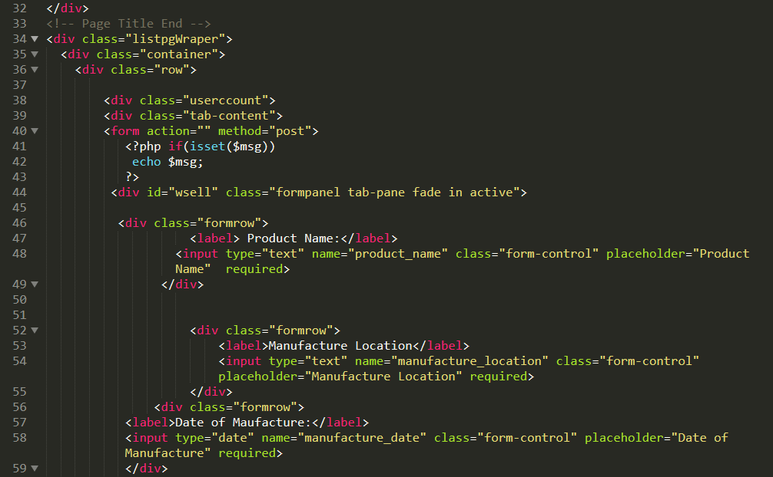

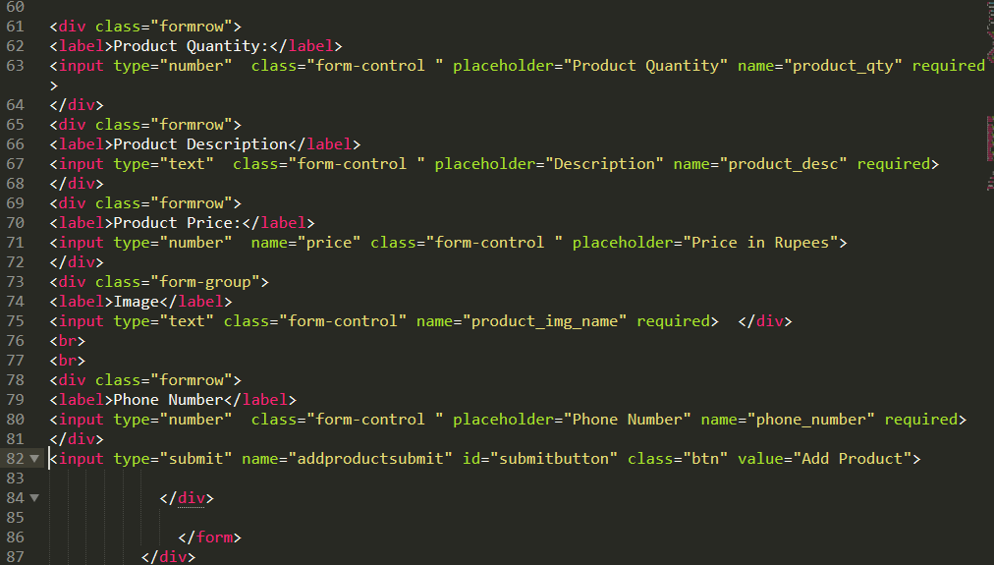

Figure 29 user add new product codes

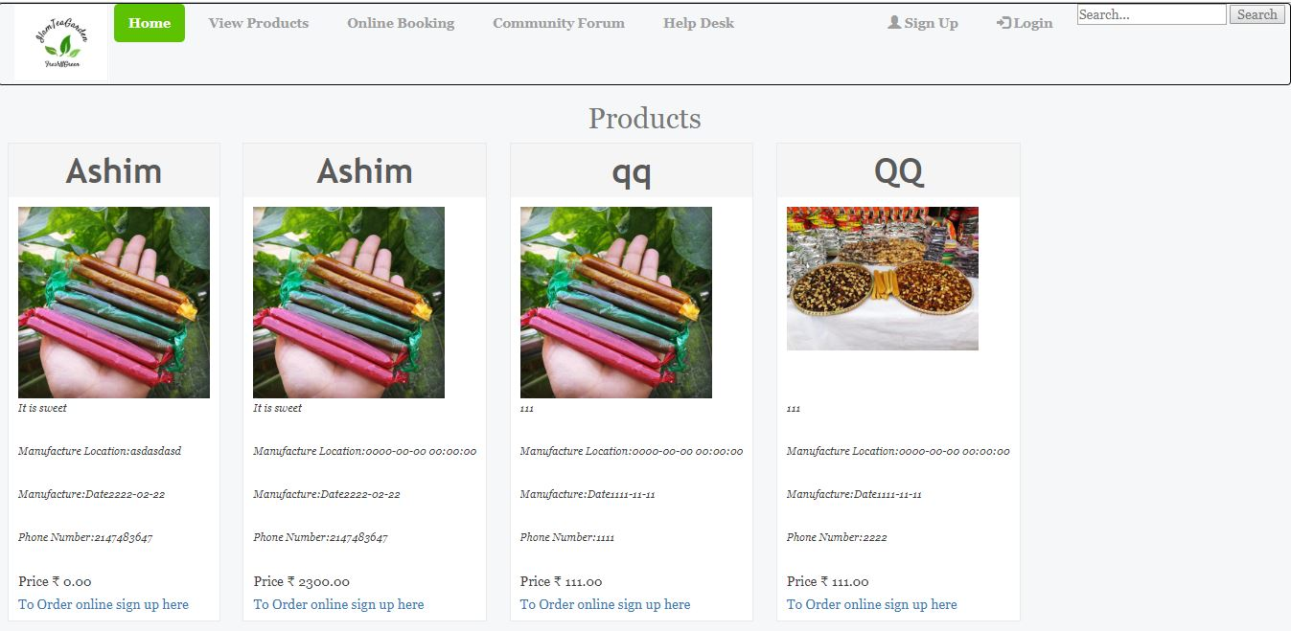

Figure 30 all user view product interface

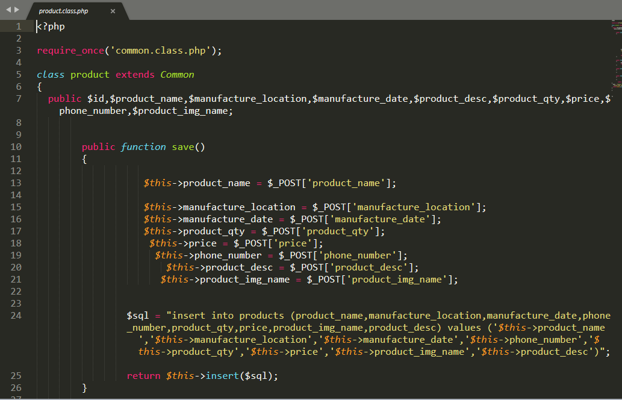

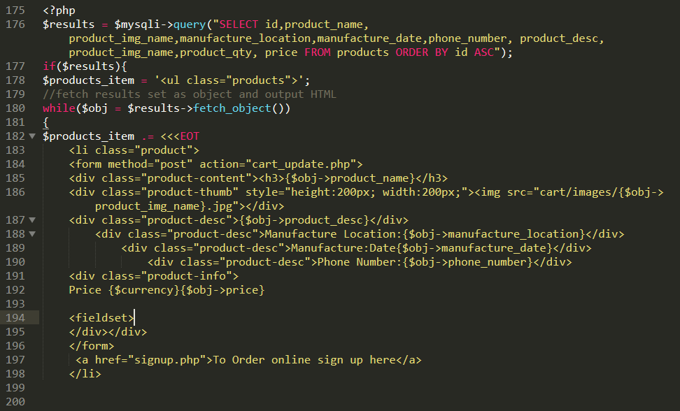

Figure 31 all user view products code

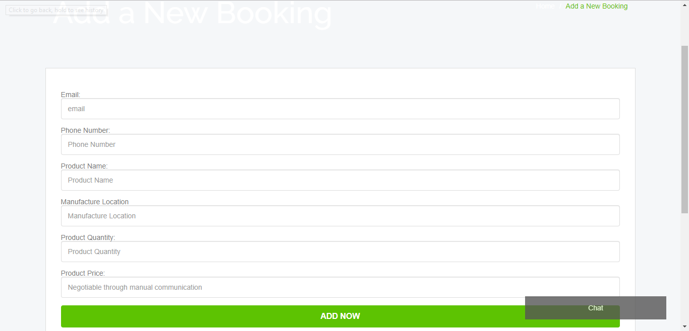

Figure 32 add new boking code interface

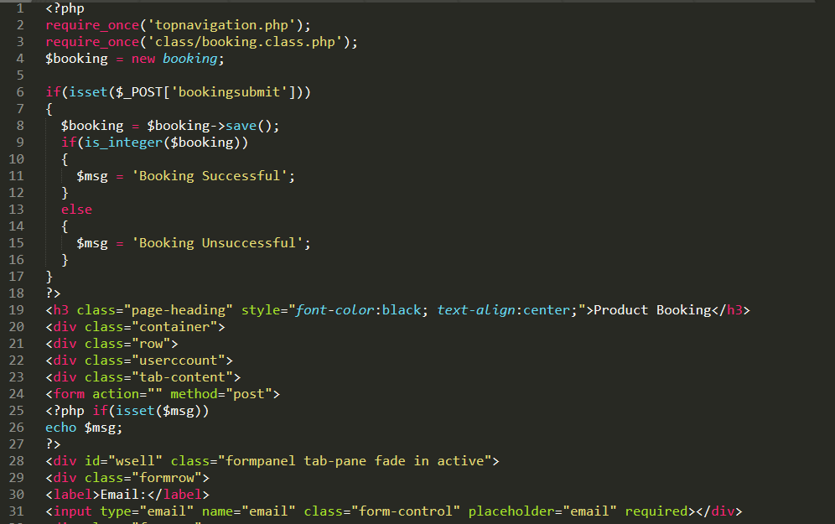

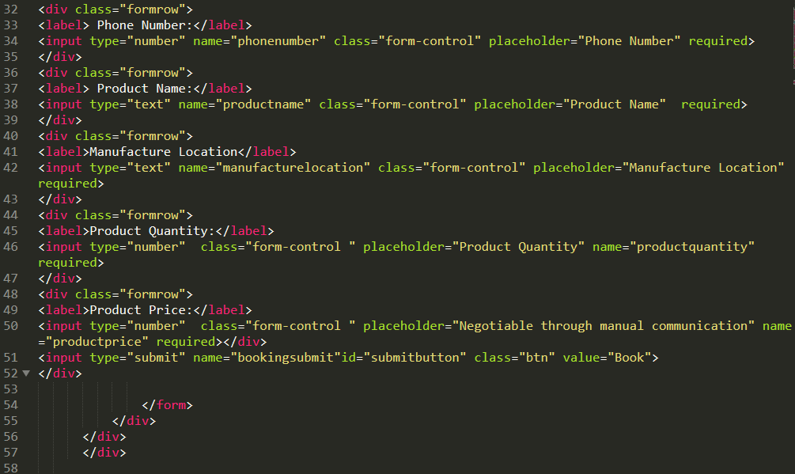

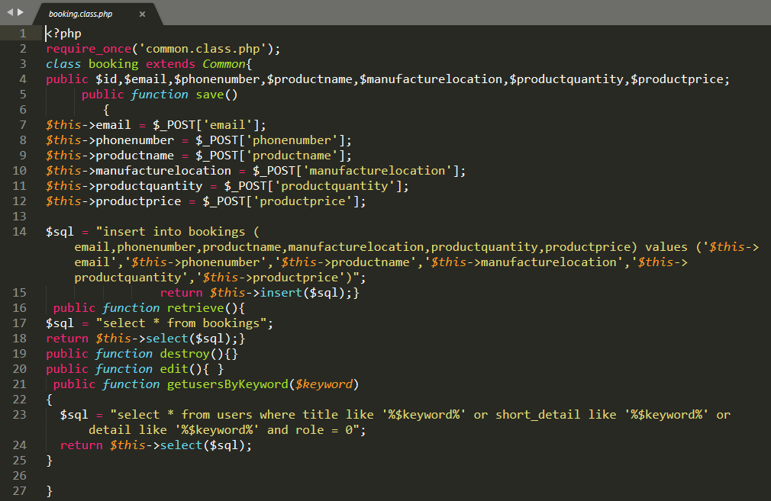

Figure 33 add new booking codes

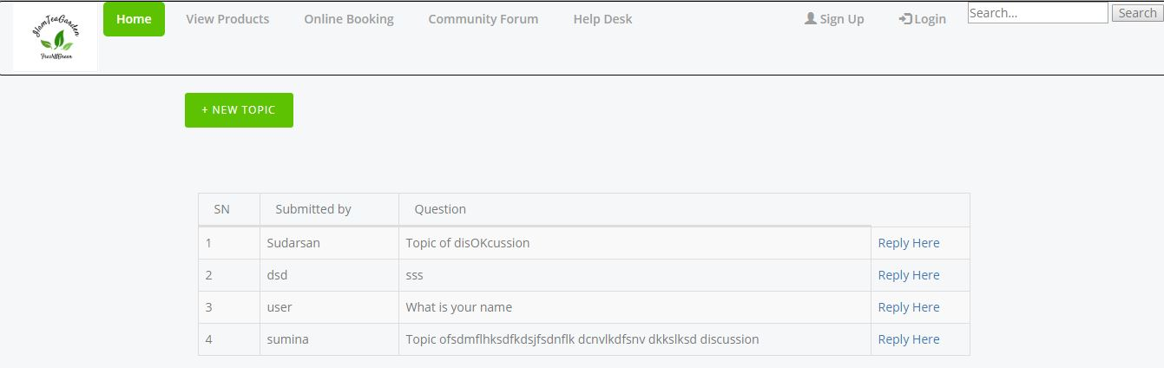

Figure 34 community forum interface

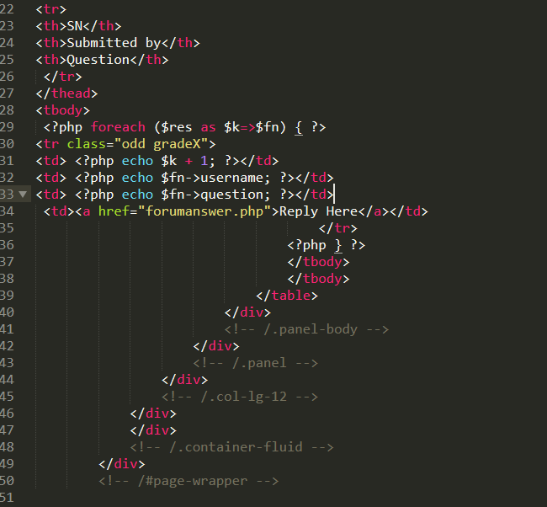

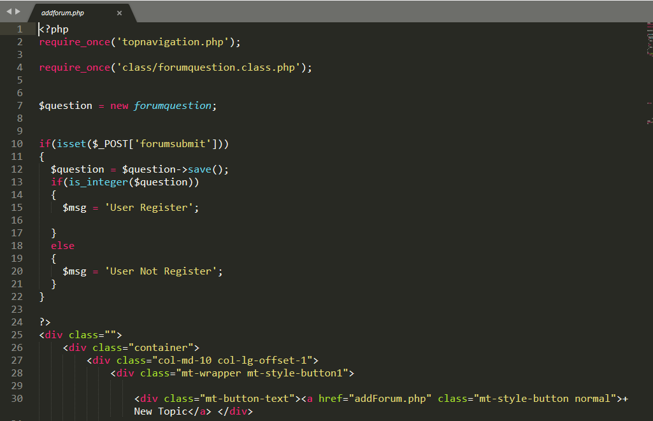

Figure 35 community forum codes'

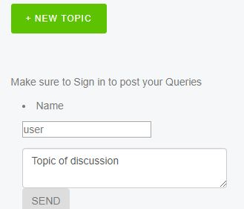

Figure 36 add new forum interface

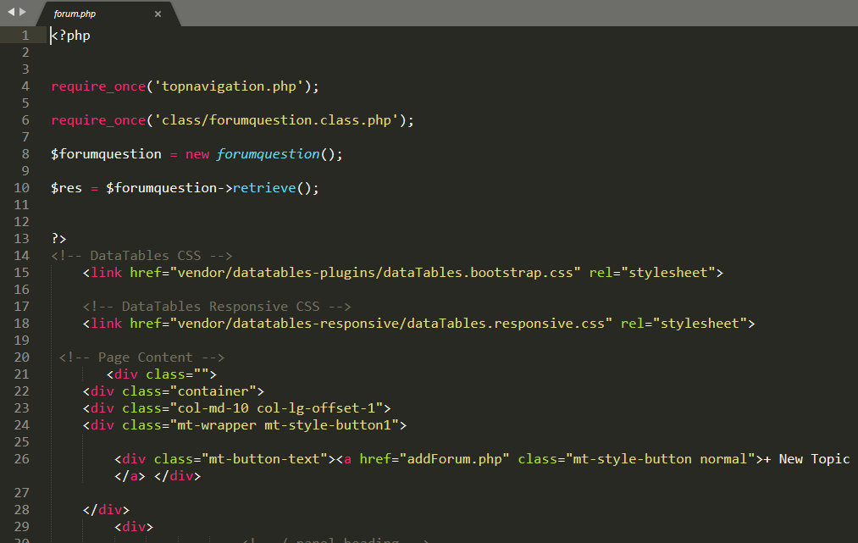

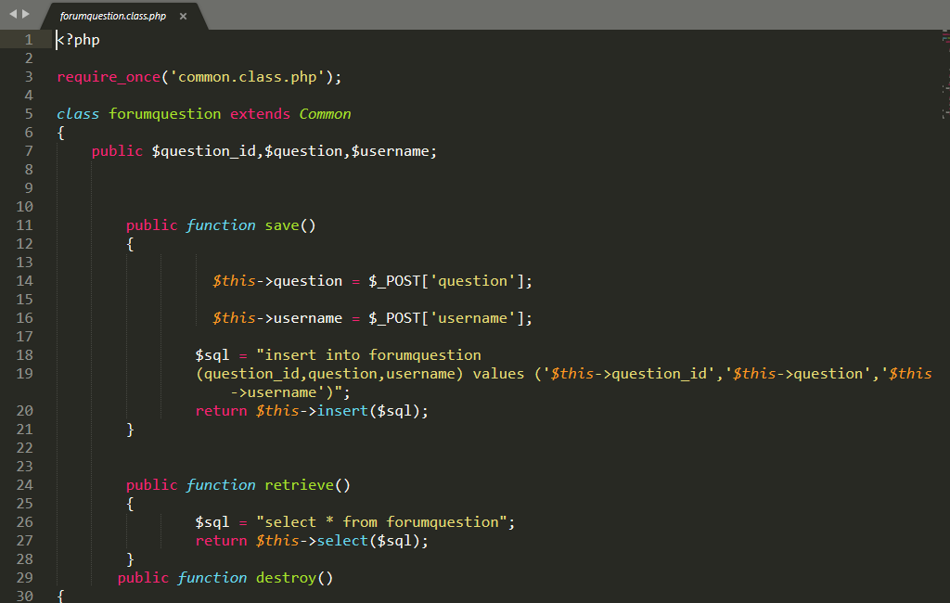

Figure 37 add new forum codes

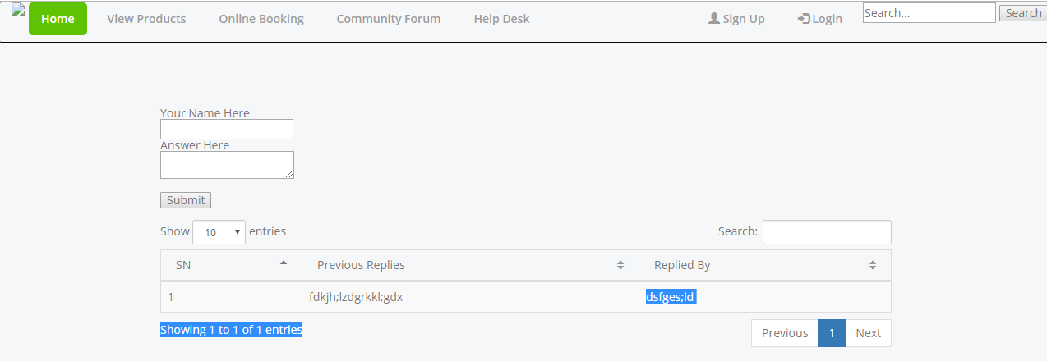

Figure 38 provide forum reply interface

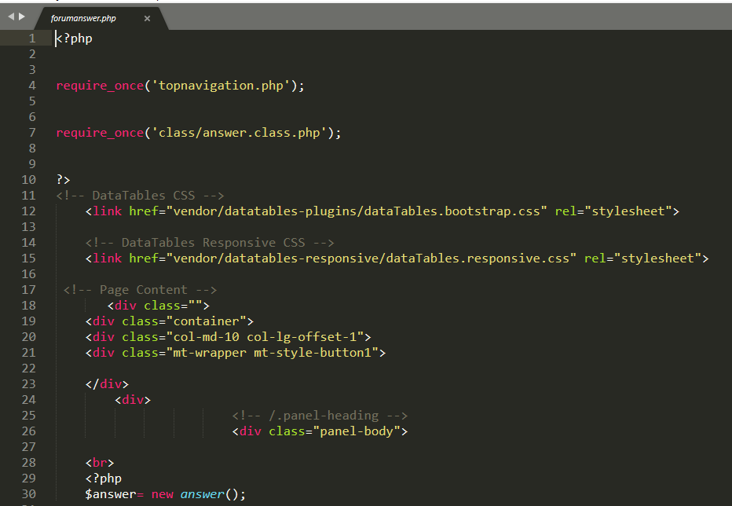

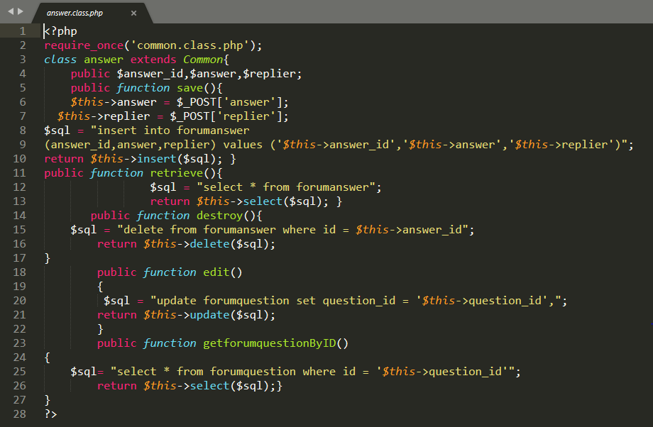

Figure 39 forum reply codes

# **Chapter 5: Testing of Ilam Tea Garden**

In software development, the process of verifying whether a software or a particular feature is performing what it is meant to perform with an additional intent to find the software related bugs and errors is known as testing. Several testing such as black box testing, white box testing unit testing are performed are performed on a developed software. Among those methods I have used Black box testing and unit testing methods.

I preferred Black box testing for my project since it is used to check whether a certain feature is actually working or not by using certain test data. In the same way I performed unit testing in order to detect error in my codes if any which would help identify and mitigate errors at the developmental phase.

## **Black Box Testing**

The process of Black Box Testing is performed below.

|  |  |  |  |  |  |
| --- | --- | --- | --- | --- | --- |
| **Title: Ilam TeaGarden** | | | | | |
| Test Case ID: T-1 to T-4 | | | Designed By: Sudarsan Udash | | |
| Test Name: Registration and Login | | | Date of Design: 14th June, 2019 | | |
| Test Description: Registration and Login Validation. | | | Executed By: Sudarsan Udash | | |
| Date of Execution: 24th June, 2019 | | |
| **Test ID** | **Test Scenario** | **Text Data** | **Expected Result** | **Actual Result** | **Result** |
| T-1 | Registration input Validation | First Name, Last Name, location, Phone Number, Email, dateofbirth, Password. | If any field is blank then error message seems. | Error Message shown | Passed |
|  | | | | | |
| T-2 | Registration | First Name, Last Name, Address, Phone Number, Email, date of birth, Password. | User must be register Successfully. | User Registered Successfully. | Pass |
|  | | | | | |
| T-3 | Email and Password | Email and Password | If the data is missing or email and password is invalid then message is seem. | Error message seemed. | Pass |
|  | | | | | |
| T-4 | Login | Email and Password | User/Admin should be valid and forwarded to respective dashboard. | User/Admin Login successfully forwarded to respective dashboard. | Pass |
| User Dashboard | | | Admin Dahboard | | |

|  |  |  |  |  |  |  |
| --- | --- | --- | --- | --- | --- | --- |
| **Title: Ilam Tea Garden** | | | | | | |
| Test Case ID: T-5 | | | Designed By: Sudarsan Udash | | | |
| Test Name: Logout | | | Date of Design: 14th June, 2019 | | | |
| Test Description: Logout Validation | | | Executed By: Sudarsan Udash | | | |
| Date of Execution: 24th June, 2019 | | | |
| **Test ID** | **Test Scenario** | **Test Data** | | **Expected Result** | **Actual Result** | **Result** |
| T-5 | If user/admin logout of the system. | Email and Password | | User/Admin must be logout of the system. | Logout successfully out of the system. | Pass |
|  | | | | | | |

|  |  |  |  |  |  |  |
| --- | --- | --- | --- | --- | --- | --- |
| **Title: Ilam Tea Garden** | | | | | | |
| Test Case ID: T-6 to T-9 | | | Designed By: Sudarsan Udash | | | |
| Test Name: Add, Update, Delete and View Flight by admin | | | Date of Design: 14th June, 2019 | | | |
| Test Description: Add, Update, Delete and View Products Validation. | | | Executed By: Sudarsan Udash | | | |
| Date of Execution: 24th June, 2019 | | | |
| **Test ID** | **Test Scenario** | **Test Data** | | **Expected Result** | **Actual Result** | **Result** |
| T-6 | Add Product | Product name, manufacture location, manufacture date, product quantity, product price, product description, image, phone number | | All the field must be filled and should be added successfully. | Product added successfully. | Pass |
|  | | | | | | |
| T-7 | Update Product | Product name, manufacture location, manufacture date, product quantity, product price, product description, image, phone number | | Changes in any data must be updated in database and view Products | Product updated successfully. | Pass |
|  | | | | | | |
| T-8 | Delete product | Product name, manufacture location, manufacture date, product quantity, product price, product description, image, phone number | | Data of products must be deleted from database and view products | Product Deleted successfully. | Pass |
|  | | | | | | |
| T-9 | View Products | Product name, manufacture location, manufacture date, product quantity, product price, product description, image, phone number | | All the details of products must be display. | All the products details viewed successfully. | Pass |
|  | | | | | | |

|  |  |  |  |  |  |  |
| --- | --- | --- | --- | --- | --- | --- |
| **Title: Ilam Tea Garden** | | | | | | |
| Test Case ID: T-10 to T-11 | | | Designed By: Sudarsan Udash | | | |
| Test Name: Community Forum | | | Date of Design: 14th June, 2019 | | | |
| Test Description: Community forum queries and feedbacks | | | Executed By: Sudarsan Udash | | | |
| Date of Execution: 24th June, 2019 | | | |
| **Test ID** | **Test Scenario** | **Test Data** | | **Expected Result** | **Actual Result** | **Result** |
| T-10 | Community Forum | First Name and Topic of discussion | | All the field must be filled and should be added successfully. | Query added successfully. | Pass |
|  | | | | | | |
| T-11 | View All Queries | Name and topic of discussion | | All the details of queries must be display. | All the queries details viewed successfully | Pass |
|  | | | | | | |

|  |  |  |  |  |  |  |
| --- | --- | --- | --- | --- | --- | --- |
| **Title: Ilam Tea Garden** | | | | | | |
| Test Case ID: T-12 to T-13 | | | Designed By: Sudarsan Udash | | | |
| Test Name: Adding Products To cart | | | Date of Design: 14th June, 2019 | | | |
| Test Description: Adding Products to cart | | | Executed By: Sudarsan Udash | | | |
| Date of Execution: 24th June, 2019 | | | |
| **Test ID** | **Test Scenario** | **Test Data** | | **Expected Result** | **Actual Result** | **Result** |
| T-12 | View Product In Shop | All Product Details | | Product Details should appear with an image | Successful | Pass |
|  | | | | | | |
| T-13 | Add to cart | Quantity and Product Name | | Shopping cart must popup | Shopping cart popped up | Pass |
|  | | | | | | |
| T-14 | Update Cart | Quantity and Product Name | | Cart must Update | Cart successfully updated | Pass |
|  | | | | | | |
| T-15 | Checkout | Product Name,Price , Total including additional charges | | Cart must show checkout | Checkout successfully shown | Pass |
|  | | | | | | |

|  |  |  |  |  |  |  |
| --- | --- | --- | --- | --- | --- | --- |
| **Title: Ilam Tea Garden** | | | | | | |
| Test Case ID: T-12 | | | Designed By: Sudarsan Udash | | | |
| Test Name: View User Detail | | | Date of Design: 14th June, 2019 | | | |
| Test Description: View User Detail Validation. | | | Executed By: Sudarsan Udash | | | |
| Date of Execution: 24th June, 2019 | | | |
| **Test ID** | **Test Scenario** | **Test Data** | | **Expected Result** | **Actual Result** | **Result** |
| T-16 | View All User Detail | First Name, Last Name, Address, Phone Number, Email, date of birth, Password. | | All the details of user must be display. | All the user details viewed successfully. | Pass |
|  | | | | | | |
| T-17 | Update User Details | First Name, Last Name, Address, Phone Number, Email, date of birth, Password. | | All the details of user must be updated | All the user details updated successfully. | Pass |
|  | | | | | | |

|  |  |  |  |  |  |  |
| --- | --- | --- | --- | --- | --- | --- |
| **Title: Ilam Tea Garden** | | | | | | |
| Test Case ID: T-14 | | | Designed By: Sudarsan Udash | | | |
| Test Name: Delete User | | | Date of Design: 14th June, 2019 | | | |
| Test Description: Delete User by admin. | | | Executed By: Sudarsan Udash | | | |
| Date of Execution: 24th June, 2019 | | | |
| **Test ID** | **Test Scenario** | **Test Data** | | **Expected Result** | **Actual Result** | **Result** |
| T-18 | Delete Profile | First Name, Last Name, Address, Phone Number, Email, date of birth, Password. | | Data of user must be deleted. | User Delete successfully. | Pass |
|  | | | | | | |

# **Chapter 6: Other Project Issues**

## **6.1 Project Limitation**

Like any other project, Ilam Tea Garden too has certain limitations. Some of those limitations are listed below.

1. The project will only be specific for marketing limited products of a limited area.
2. The project will only be applicable for our country for now.

## **6.2 Future Work**

There are certain features which the project lacks today but could possibly be in the future. The future activities that could be performed on the project are.

1. GPS System

Development of an online location tracking system to track through user location deliver products successfully. This is an important feature for future that can massively change the efficiency of the system.

1. Android Application

Developing an android application could enhance the usability of the product at different scales and market.

## **6.3 Other Project Issues**

Several issues appeared during the development of this project and some of those issues are described below.

* Issues with XAMPP software: A major issue of XAMPP not running the localhost came at the start of the implementation phase.

Solution: Completely removing and reinstalling XAMPP software along with some modifications led to the software running throughout the project smoothly.

* Lack of skill on Object Oriented Php

Being new to object oriented php, it was difficult to get used to the language.

Solution: Thorough practicing helped it make easier.

* Issue of workflow: A major issue of workflow occurred while creating different forms of same nature. One change in form effected other codes as well.

Solution: Backtracked and made every forms unique to each other.

## **6.4 Risk Management**

Risk Management is the process of identifying different risks related to a project and undertaking viable solutions based the threat level of the risks. Every project will have risks and the impact of those risks to the business.

Some of the risks identified for this project are:

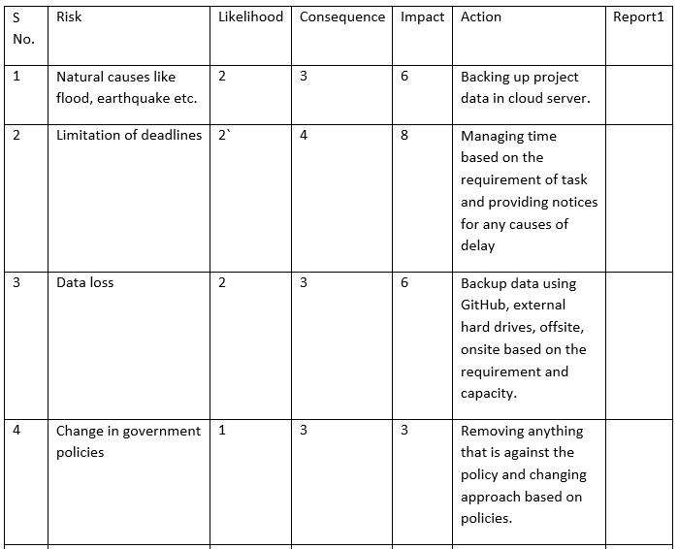

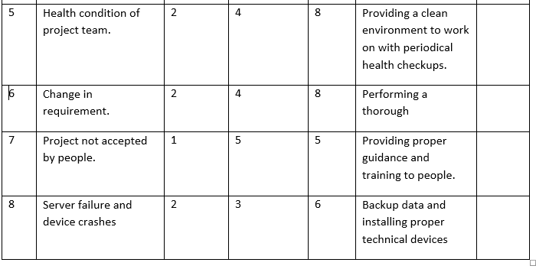

* Limitation of deadlines

This risk was solved by following the milestones of my project accurately. Each phases were completed in its designated time frame so no phases crossed its deadlines limitations.

* Data Loss

There wasn’t any loss of data since every updated project activity was uploaded in my GitHub account as well as a separate file was created for backup.

* Change in requirement

Since the requirement of the project was clear from the beginning, there wasn’t any change in the requirement of the project later.

* Server failure due to devices crashes

This did not occur.

## **6.5 Configuration Management**

The process of handling the system changes in a systematic way in order update the system while maintaining the integrity of the system is known as configuration management. It helps to maintain the consistency of the system no matter the change in functionality, and other physical attributes of the system.

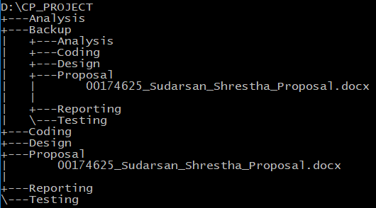

Figure 12 Configuration Management

The above configuration management has been made under the following guidelines.

A folder named CP PROJECT is created in the D drive with subfolders of different of development and also a backup file to protect the project. Each subfolder has an individual file related to the phase. When configured using Command prompt, a configuration tree is formed as shown above. I have also configured a backup file for my project to ensure that data loss does not happen due to various risk factors.

Also the project has been uploaded to GitHub with account

Github id: <https://github.com/SudarsanUdash>

Repository address: <https://github.com/SudarsanUdash/SudarsanUdashCPProposal/blob/master/Mycpproject.docx>

## **6.5 User Help Desk**

A user help desk is a section of a project where users can learn how to use the system. It contains as much information about the project as required. The help desk of Ilam tea garden is present in the snippets below.

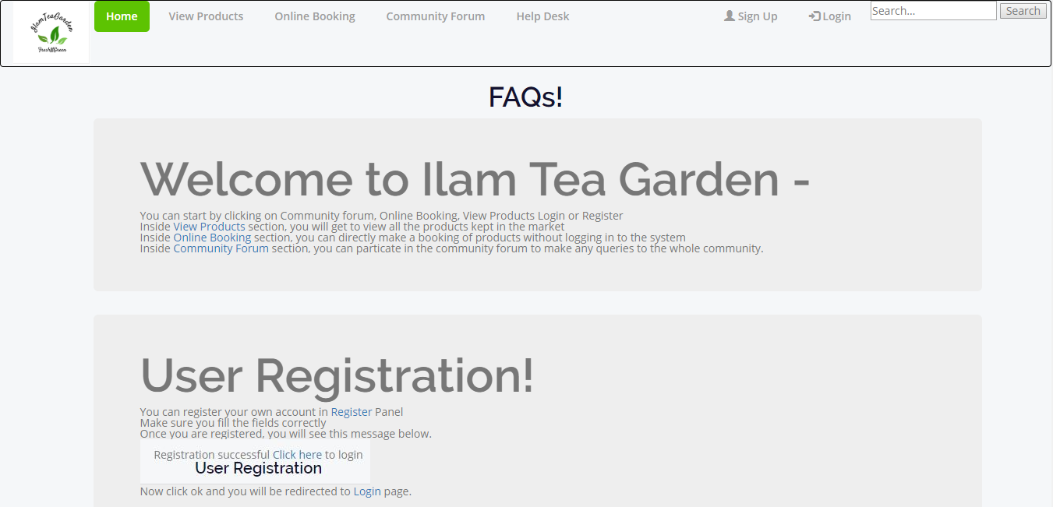

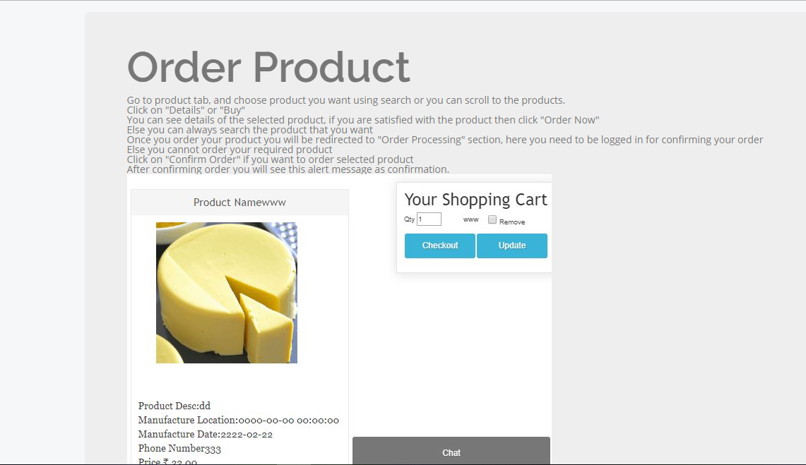

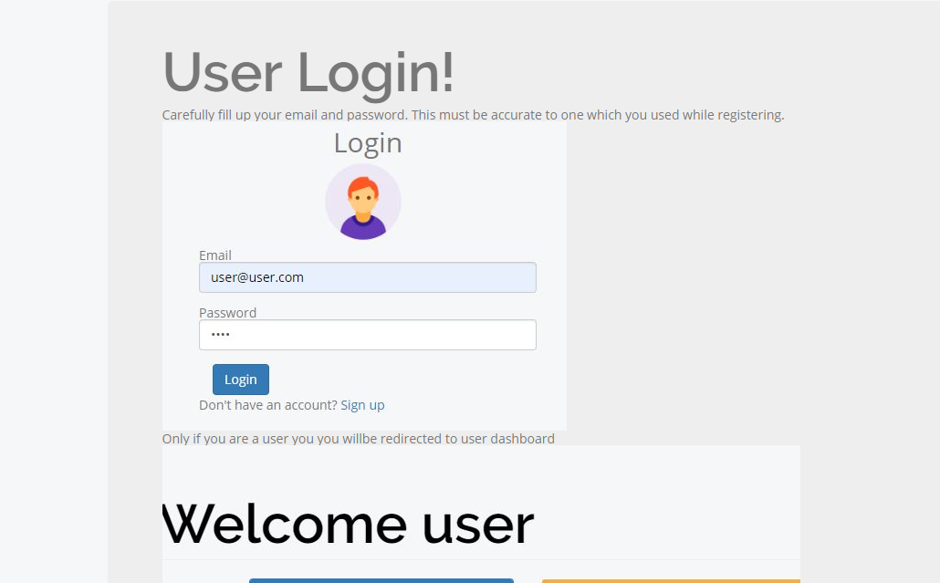

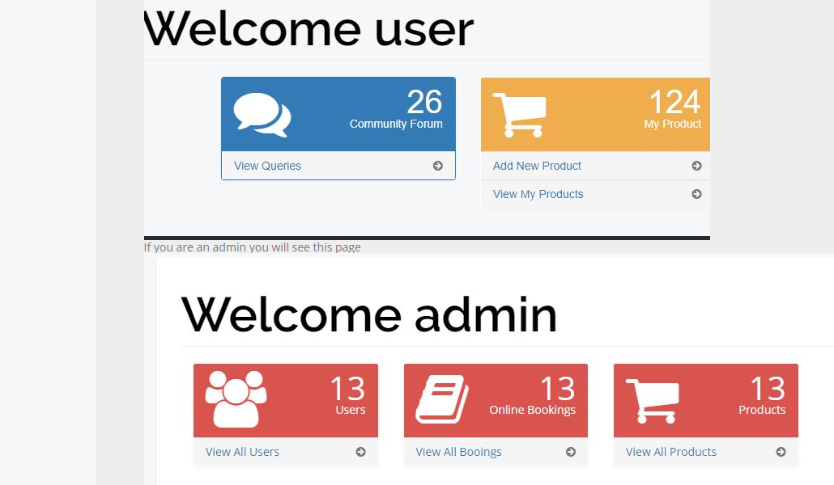

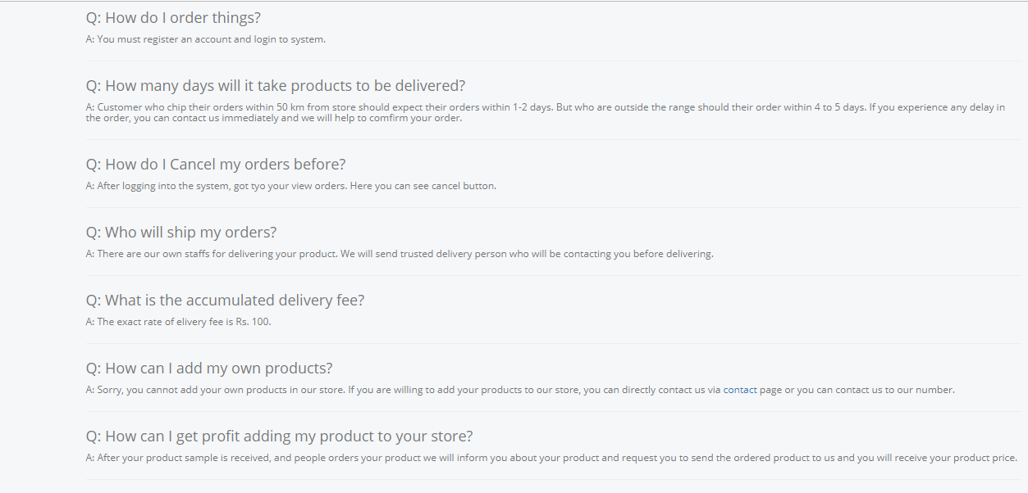

# **Chapter 7: Conclusion/Summary**

Starting the project on 25th March 2019, the proposal for project Ilam Tea Garden was submitted. It mentioned different aspects of the project including its introduction, background, objectives and also set a guideline for the whole project with the development of Gantt chart and milestones.

Requirement analysis was one of the most interesting phase of the project since there wasn’t any other project in the past connected to this product. It was a new perspective to analyze what this product could do and to understand whether this project is possible in the rural society like Ilam. Project development methodology was chosen for the project to be waterfall model since it’s a traditional approach. Functional and nonfunctional requirements for the project was set up which may or may not lack in some ways. MoSCoW prioritization helped predicted the instant requirement of the project and what we could do in the future.

Design of the project was made as easy as possible by using as much font awesome icons as possible. Pictures and icons were given larger viewing space in the project since most people from Ilam who the project is targeted for are not very good at understanding the language. Different diagrams were created to develop the structure of the project and provide a working foundation for the implementation process.

Although objected oriented Php was a complete new approach for me, with learning practicing I was able to understands its concept and how it works. There can be flaws in the coding which can be mitigated in the future. Testing was performed to check the functionality of the system.

A documentation for the whole project phases is created which can provide any help in the future or to backtrack the development of this project. Although several problems were seen during the project like lack of resources and knowledge, practicing and following guidelines were the key efforts in the whole project. The expectations I had while starting the project was far from the reality I faced during the whole project, but the knowledge gained during this whole project of Ilam Tea Garden was unimaginable.

# **References and Bibliography**

<https://www.quora.com/What-is-the-importance-of-analysis-and-design-in-software-engineering>

<https://www.synapseindia.com/6-stages-of-software-development-process/141>

Susan Gasson, OR/S Group, Warwick Business School October 1994

<http://cci.drexel.edu/faculty/sgasson/Vita/UseOfSSM.pdf>

<https://www.w3schools.com/>

<https://www.lucidchart.com/pages/how-to-draw-a-sequence-diagram-in-UML>

<https://www.codeofaninja.com/2013/04/shopping-cart-in-php.html>